CIVIC SOLIDARITY PLATFORM
STATEMENT ON POLITICAL CONTROL OF THE MEDIA IN UKRAINE
23 JULY 2012

We, the undersigned members of the Civic Solidarity Platform, urge the Council of Europe, EU institutions and member states and the OSCE to immediately call upon the Ukrainian authorities to put an end to restrictions on freedom of expression and the on-going political interference with the media in Ukraine.
The freedom of expression situation has worsened in Ukraine since 2010. We were deeply disturbed to learn that, on 12 July 2012, just three months before the parliamentary elections, Ukraine's tax police raided the office of the only independent national television station in Ukraine, TVi, as part of a criminal investigation for large scale tax evasion by its head, Mykola Kniazhytsky.
The timing of this latest investigation, potentially crippling the broadcasting of TVi before the parliamentary elections, is particularly suspicious, and seems to be yet another attempt to limit Ukrainian broadcasting in its diversity and plurality, censoring independent voices through legal means.
The political censorship of channels, such as TVi, raises numerous questions regarding the lawfulness of interference in the activities of independent media in Ukraine as well as equal treatment of all television channels. Moreover, on 20 September 2010 the Council of Europe Parliamentary Assembly already raised concerns about developments that could undermine the principle of media pluralism in Ukraine. The situation of media pluralism in Ukraine has been deteriorating ever since.
In September and October 2011 the OSCE Representative on the Freedom of the Media also called upon the Ukrainian authorities to restore media pluralism and ensure transparency of media ownership. Simultaneously on 25 October 2011 the European Parliament issued a resolution on developments in Ukraine in which MEPs expressed concerns concerning the deterioration of media freedom and pluralism in Ukraine and called on the authorities to take all necessary measures to protect these essential aspects of a democratic society and to refrain from any attempt to control, directly or indirectly, the content of national media reporting.
Media pluralism, as an element of freedom of expression, has been underlined on many occasions by the European Court of Human Rights. In its judgments (e.g. case Frasilă i Ciocirlan p. Rumunii application no. 25329/03, judgment issued on 10 May 2012) the Court highlights positive obligations of the state to ensure broadcasting activities by journalists and media owners and underlines that States should also institute mechanisms which would not hinder journalistic activities, especially in the period before elections, where the public should receive pluralistic information about candidates.
The on-going political interference with the media is even more worrying in light of the EU-Ukraine agreement which is due to be signed in the next few months. Freedom of expression and media pluralism are enshrined in the EU Charter of Fundamental Rights. The EU Commission finalised in 2011 the “Three-step approach for advancing the debate on media pluralism” which highlights the importance of media pluralism as an element of democratic society. Moreover, according to the EU-Ukraine Agenda adopted on 24 November 2009, Ukraine committed itself to promote “the legal and administrative framework necessary for the enjoyment of freedom of expression with a particular emphasis upon the mass media and the rights of journalists”.
Despite its international commitments, Ukraine continues to violate media pluralism and freedom of expression. Therefore, increasing political control over the media in and interfering with the right to freedom of expression in Ukraine must be treated as an extremely urgent matter and the international community should immediately call upon the Ukrainian authorities to put an end to the on-going political control of the media.

Albanian Helsinki Committee

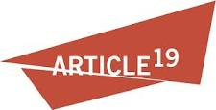 Article 19

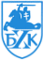 Belarusian Helsinki Committee

 Belarusian Human Rights House in exile, Vilnius
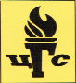 Centre for Civil Liberties (Ukraine)

 Centre for the Development of Democracy and
Human Rights (Russia)

Freedom Files Freedom Files (Russia)

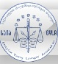 Georgian Young Lawyers’ Association

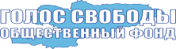 Golos Svobody (Kyrgyzstan)

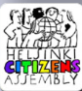 Helsinki Citizen’s Assembly – Vanadzor (Armenia)

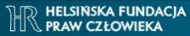 Helsinki Foundation for Human Rights (Poland)

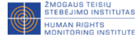 Human Rights Monitoring Institute (Lithuania)

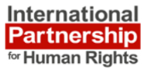 International Partnership for Human Rights (Belgium)

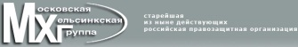 Moscow Helsinki Group

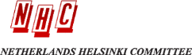 Netherlands Helsinki Committee

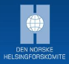 Norwegian Helsinki Committee

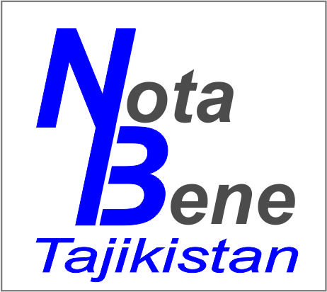 Nota Bene (Tajikistan)

 Promo LEX Association (Moldova)

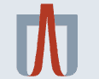 Ukrainian Helsinki Human Rights Union

