Ukraine

Report to the UN Universal Periodic Review

Fourteenth session of the UN Human Rights Council on Universal Periodic Review 2nd cycle

2012

Coalition of NGOs submitting the report:

- NGOs’ Coalition “The Rights of a Child in Ukraine” (e-mail: crc.ngo.ukraine@gmail.com) that includes:
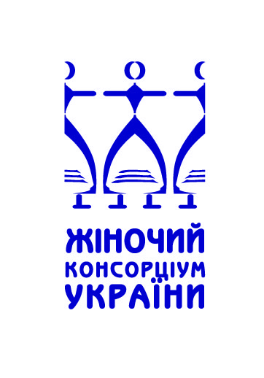 |  |  | 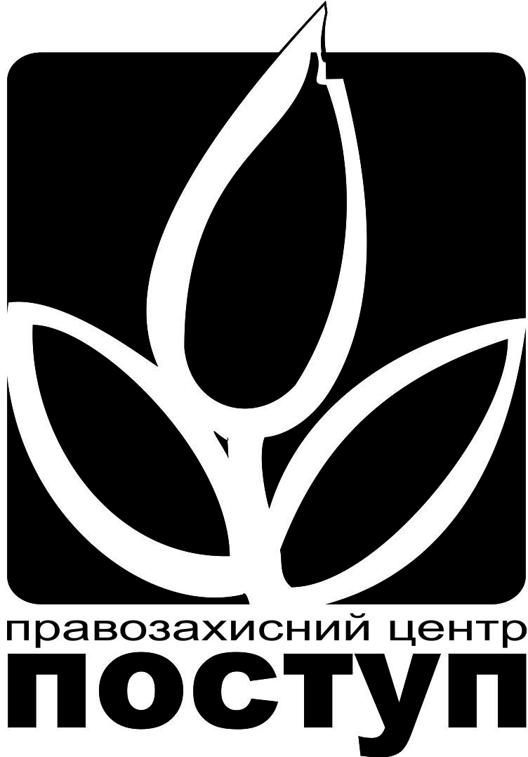 |  | 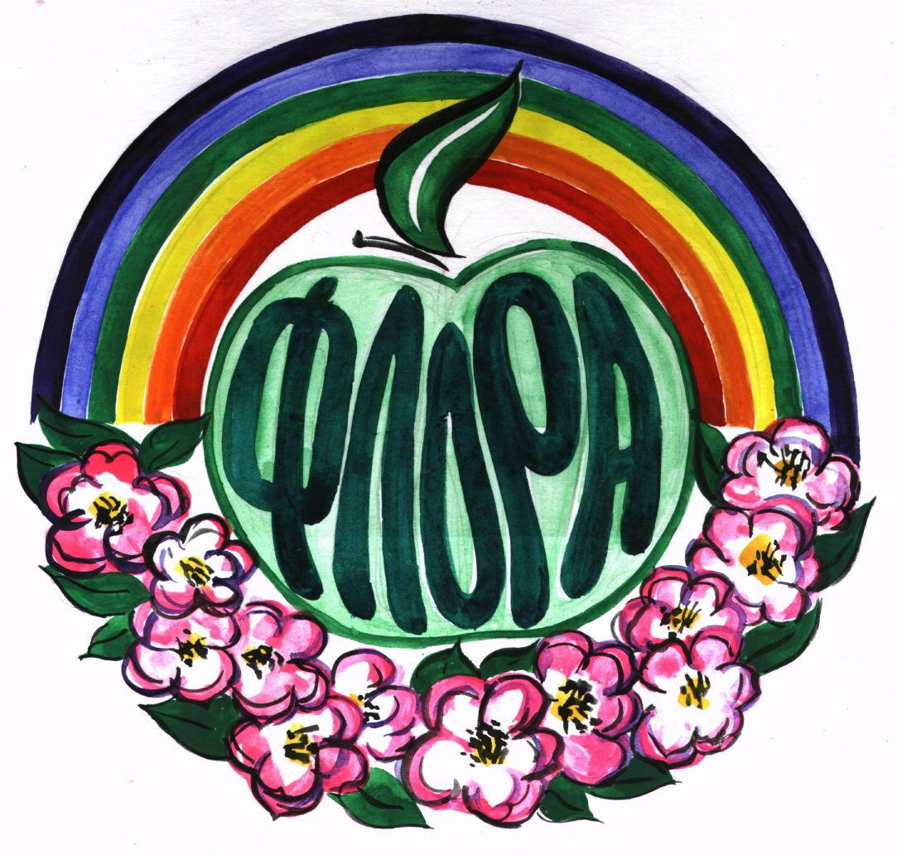 |  | 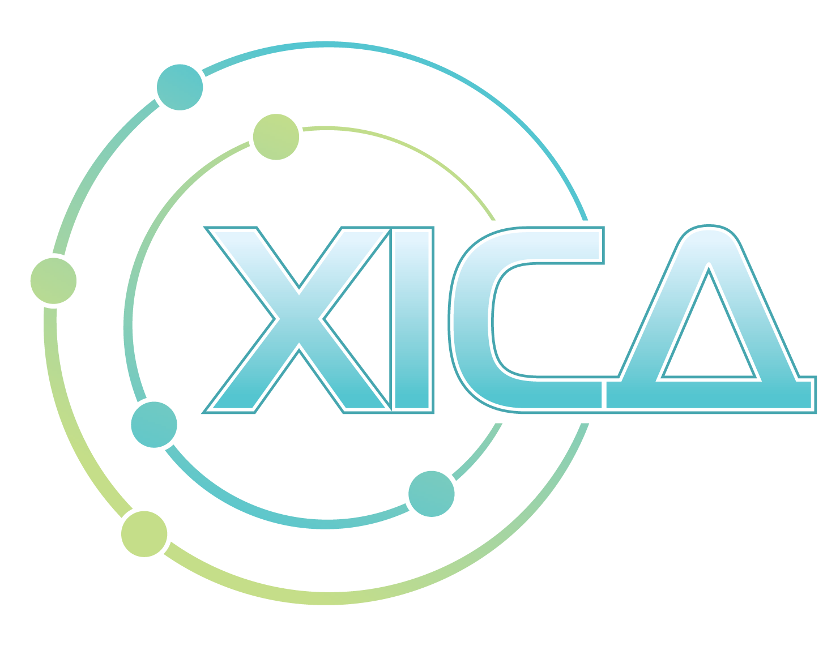
ґЕНДЕРНА АГЕНЦІЯ КОНСУЛЬТАЦІЇ    ТА ІНФОРМАЦІЇ  СУМСЬКА ОБЛАСНА МОЛОДІЖНА  ГРОМАДСЬКА ОРГАНІЗАЦІЯ  група ІБФАН-Суми  член Міжнародної мережі дій  в сфері дитячого харчування |  |  |  | 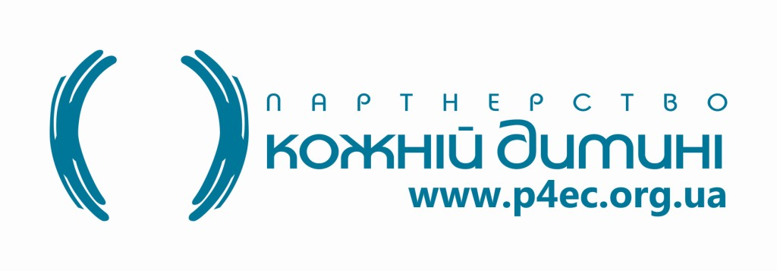
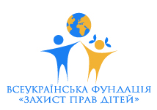 |  | 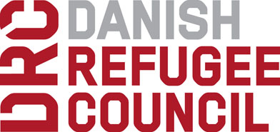 |  |  |  | 

2. International women’s human rights center “La Strada – Ukraina”,

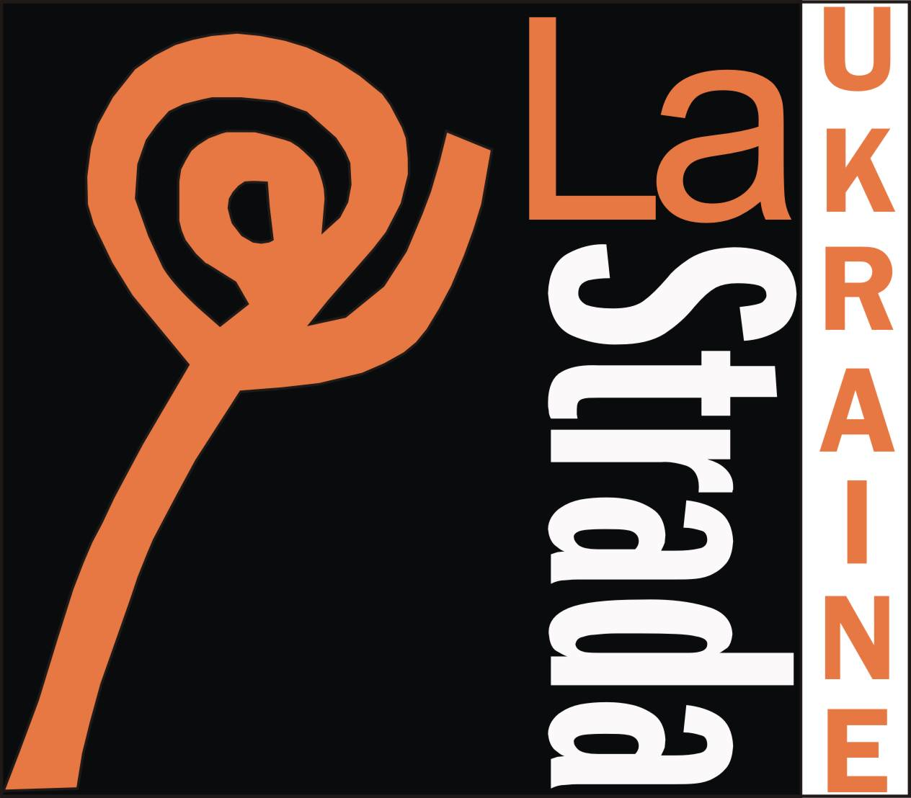 | P.O.Box 26, Kyiv 03113. +38 044 205 36 95 info@la-strada.org.ua www.la-strada.org.ua

3. All-Ukrainian network for counteracting commercial sexual exploitation of children


The Coalition presenting this submission is an informal association created in February 2012 specifically for joint preparation of this report. It allows covering the issues of children’s rights in Ukraine most fully and comprehensively. It consists of formalized structures, i.e. 11 non-governmental organizations.

The NGOs’ Coalition “The Rights of the Child in Ukraine” sees its goal in monitoring the children’s rights in Ukraine, following the recommendations on children’s rights issued by UN Committee on the rights of the child within the framework of the UN Convention on the rights of the child and in promoting their realization; sharing best practices in ensuring adherence to the rights of the child; International women’s human rights centre “La Strada – Ukraine”, set up to prevent human traffic, promote the liquidation of all forms of discrimination and violence in society, safeguarding the rights of the child etc (unites 23 NGOs and 2 individual members), is a branch of international ECPAT organization.

Coalition “The Rights of the Child in Ukraine” includes

- All-Ukrainian Foundation “Protection of Children’s Rights” 03150, Kyiv, Predslavinska str. 49, office. 4, phone. +38(044)3319898, jane_p@ukr.net
- All-Ukrainian NGO “Women’s ConcortiumConsortium of Ukraine”, Kyiv, Kostelna str. 10, apt.. 28, phone. +38(044)5926854, info@wcu-network.org.ua, http://wcu-network.org.ua
- Association of young professionals “Class” 61034, Kharkiv, p.o.box 3058, phone +38(067)5747902, kolena2000@ukr.net, contact@class.org.ua
- City youth NGO “М’АRТ”, 14000, Chernyhyv, p.o.box 79, phone . +38(0462)774110, mart.ngo@googlemail.com
- Danish Refugee Council, 01034, Kyiv, Pushkinska str. 2-4/7, office 9, dina.gud@drc.dk
- Children’s Environmental organization “Flora” 25015, Kirovohrad, Yegorova str., 19, apt.. 2, phone. +38(052)2270463, flora2000@inbox.ru, http://childflora.org.ua
- Human rights center “Postup”, 91050, Luhanks, 30-letia Pobedy str. 2, apt.. 50, phone +38(050)6235846, reutski@gmail.com, http://postup.lg.ua

Kharkiv Institute of Social Researches, 61057, Kharkiv, Sumska str. 4, office.25, phone.+38(057)7511525, 760 46 23, www.khisr.kharkov.ua
- Kharkiv regional foundation “Public Alternative”, 61103, Kharkiv, Lenin Avenue, 72/48, phone.+38(050)4023456, public.alternative@gmail.com
- Partnership “For Every Child” in Ukraine, 01032, Kyiv, Kominterna str. 28, phone +38(044)3590210, info@everychild.org.ua, http://www.everychild.org.ua
- Sumy Oblast Youth Organisation “Gender agency of counsultation and information”, 40030, Sumy, Antonova str. 1/41, phone. +38(050) 9249433

- During the first cycle of Universal Periodic Review in 2008, Ukraine accepted a number of recommendations with respect to the child’s rights. Among them – accelerated setting up of juvenile justice system; further protection of children against human trafficking and fight against child prostitution, pornography and child’s work, providing services for the children – victims of domestic violence. The advice to adhere to provisions of the UN Committee on the Rights of the Child presented a separate set of recommendations. Taking the fact that in February 2011 Ukraine received new recommendations from the UN Committee, the Coalition decided to focus this report on the State achievements.
- In implementing these recommendations, enumerating systematic problems, calling for special attention, as well as concentrating on the issues of juvenile justice system and prevention of children’s trafficking, their sexual and labour exploitation.
- Ukraine has made first steps in the implementation of the UN Committee on the Rights of the Child recommendations; however, these steps are non-systematic and uncoordinated; not supported by stable legislative basis and often are of formal nature; real interests of the children are not analysed or taken into account; role of non-governmental organizations in setting up governmental policy with regards to children remains weak. The following issues still remain most problematic from the point of view of adherence to children’s rights and their ensuring by the state: comprehensive system of children’s rights protection; distribution of competences between state bodies after administrative reform; non-existent efficient response mechanisms to the child’s rights’ violations; introduction of really independent institute of Ombudsman on the child’s rights; violation of the child’s right to have family and punishment of parents in a complicated situation, etc.
Bringing legislation into compliance with the Convention on the Rights of the Child
- Over the year 2011 the state proposed new legislative initiative, aimed at more accurate reflection of the norms of Convention on the Rights of the Child into the national normative and legal basis, according to the UN Committee on the rights of the child recommendations of в February 3, 2011. The proposed laws address the issues of adoption, social security for the families with children, children’s property, acquiring the refugee status, registration of the newborns, counteracting human trafficking, observance of the rights of the disabled children, the child’s rights in the criminal process et al. However, systematic and consistent steps in this direction have not been taken; while the UN Committee on the Rights of the Child recommendations on passing a comprehensive Law on the child’s rights have not been fulfilled either. Besides, the amendments are introduced, mainly, at the Presidential Decrees level, almost equal to the Law under the current Constitution, but less stable. They also leave less room for public discussion and envisage less transparent procedures.
Coordination of functions and distribution of competences among the executive authorities
- After administrative reform of 2011, the system of children’s rights protection did not become more strictly defined or coordinated. The responsibility was distributed among various ministries and departments, whose collaboration was inefficient or non-existent at all. The Ministry of Social Policy (MSP) is the main coordinating governmental body of executive power with respect to families and children. At the same time, the competences in developing State Program for family support have been entrusted by Prime-Minister to the Ministry of Education, Science, Youth and Sports (MESYS). The Presidential Representative for the child’s rights often duplicates the functions of the MSP in devising state strategy for the child’s rights, although this position does not envisage these competences. The Department for the Protection of the Child’s Rights and Adoptions, which has been proactive under the auspices of the MESYS prior to reform, started its operation under new subordination, i.e. to the MSP– only in November 2011, almost a year after reform was carried out.
- The role of the Interagency Commission on the issues of childhood protection, whose goal is “to promote the realization of the state policy in childhood protection, coordinate the activities related to the well-being and development of the children, as well as their involvement in political, cultural and spiritual state-building, implementing the measures envisaged by the UN Convention on the rights of the child”, and also charged under the National Plan of Action on realization of the UN Convention on the Rights of the Child with the duty “to conduct monitoring and assessment of the Program ensuring children’s rights and freedoms” not only does not increase, but remains vague. Currently the Commission does not work at all.
- The State Department for Supervision of Adherence to Labour Legislation has been liquidated. Currently it undergoes re-organization and delegation of its functions to other bodies, but in the meantime one can conclude that the legislative/regulatory work on children’s labour and exploitation is not coordinated.
Setting up an independent institute of Ombudsman on Children
- Introduction of the Presidential Representative for the Child’s Rights (PR) who started operating on August 11, 2011 was welcomed as a new additional mechanism, aimed at strengthening of the child’s rights observance. The Representative’s competences include “constant monitoring of adherence to the constitutional child’s rights, fulfilment of international obligations and submission to the President, in due order, of proposals aimed at banning and preventing the violations of rights and lawful interests of the children; submissions of draft laws proposals and Presidential decrees; introduction of measures aimed at raising public awareness”. However, the legal status of the PR is not aligned with the requirements of Paris Principles concerning independence of national human rights institutions the newly formed structure is accountable to the President directly and does not have either sufficient guarantees for independent operation or supervisory authority.
- The operation of the Parliament Ombudsperson’s Special Representative for the Child’s Rights, Equality and Non-Discrimination remained inconspicuous and inefficient in 2011. The agency’ updated website offers no information on Special Representative and no section addressing child’s rights.
Funding of the National Action Plan on the Convention on the Rights of the Child implementation
- The rate of funding the measures envisaged by the National Action Plan (NPA) on implementation of UN Convention on the Rights of the Child for the period till 2016, remains low, as pointed out in the Ukraine report on implementing UN Convention on the Rights of the Child in 2011: “In 2010 financing of the NPA constituted about 2% of needed amount. In 2011, the real amount of funding needed has been calculated. It is 5 times higher than last year’s funding”. In 2011, 161561, 69 thousand UAH was allocated for the NPA, with the major portion of expenses to be spent on leisure and resort. Funding of other planned events and measures within the NPA was not envisaged. By the early March 2012 the issue of funds allocation for 2012 was not resolved.
Information materials on the UN Convention on the Rights of the Child and specialists’ training
- The systematic training for the specialists working in different institutions in the areas related to child’s rights protection is absent at the state level. The only educational institution offering training course “Child’s rights protection” is Luhansk institute for pedagogical staff upgrading.
- Dissemination of materials on Convention at the state level is sporadic, the quantity is limited. Often materials contain erroneous explanations of the Convention provisions. The colourful materials of high quality are published predominantly for the money of UN Children’s Fund (UNICEF) and NGOs project operation.
Collaboration with civil society
- Recent legislative initiatives created favourable conditions for broader participation of the civil society in the process of decision-making. Thus, public councils are being set up under state institutions. However, the majority of public councils are functioning formally. Under the law such councils should publish information on their operation and recommendations. Meanwhile there is no information on councils’ operation within the MSP, which is another fact testifying incapability or inertia.
- State cooperation with NGOs is developing predominantly within the framework of non-formalized working groups on specific issues. This is the reason for non-transparency and non-openness of the process.
- The Public Advisory Council, set up under the PR for the child’s rights on November 14, 2011, can serve as a good example of cooperation. It units 40 organizations. The process of the Council formation was transparent; the information was widely publicized. Nevertheless the Council by-laws need amendments aimed at broadening its members’ competences and enhancing transparency of its advisory body operation: as of today the Council is headed by the Representative himself; he appoints the Secretary, while the members can be expelled by PR decision and not by voting. There are certain obstacles for regional NGOs participation in the consultations with the PR as: 1) they are not members of the public council; 2) meetings with the NGOs are not envisaged by the standard plan of the PR visits to regions. Practically it means that the possibility of meeting PR fully depends on his good will and good will of local authorities.
Support of children’s and youth organizations promoting intercultural dialogue, tolerance and respect of diversity
- The state funding of children’s and youth organizations is realized by the Departments for Families’ Affairs, Youth and Sport (DFYS) under oblast administrations, funds are distributed on the basis of projects’ selection. The main criteria are defined by the tasks of the State Target Social Program “Youth of Ukraine”. The list of priorities does not contain events promoting intercultural dialogue, tolerance and respect of diversity. That’s how the State justifies the lack of funding for events/projects, aimed at promoting intercultural dialogue, tolerance and respect of diversity.
- The current Action Plan for migrants integration into the Ukrainian society stipulates developing programs and introducing courses aimed at involving the migrants’, and, specifically, refugees’ children into educational process and their adjustment in the school environment within the system of comprehensive secondary educational institutions in line with European Union recommendations.
Protection of children from most vulnerable categories of society and street children
- The monitoring system for the evaluation of children from the risk groups as well as comprehensive state strategy exists only on paper – as shown by the constantly growing number of children who apply to NGOs’. As a rule, such children – due to their specifics – face discrimination in obtaining services from public institutions, and, first of all, from the law enforcement bodies. The mechanism of internal control of quality in militia and prosecutor’s office investigation with respect to violation of the rights of children from the risk groups is absent. Moreover, the dependent position of a child, pressure on a child put by the law enforcement officials make the efforts to reinstall child’s rights even more complicated, depriving children of opportunity to make militia violations public.
- Over the recent years the question of changing the subordination of criminal militia on children’s rights from criminal block to public safety block has been tackled several times. This measure together with banning of its criminal investigation activity would substantially increase the efficiency of child’s rights protection and allow for timely identification and registration of the potential risk families. However, currently the status of the Department is reduced to that of an Office, and the Presidential initiative on setting up juvenile militia is under consideration.
- The practice of imposing curfew is becoming more and more widely spread. This practice is not regulated by the legislation and is used at the discretion of local authorities.
The problem of newborns’ and mothers’ mortality
- Lethality index among newborns constituted in 2011, as well as in 2010, 9.1. Mothers’ mortality index does not show any tendency towards decrease: over the year 2011 it increased for 17.6 to 17.8 .
Access to newborns’ registration, child’s right to nationality/citizenship
- In September 2011, amendments aimed at specifying the procedure for the registration of a child born outside medical institution, were introduced into the Law “On State Civil Registry”. Penalties for delayed registration were introduced.
- Under the Law, a child born in Ukraine by foreign parents residing in Ukraine legally has a right to claim Ukrainian citizenship. The Law, however, defines legal residence in Ukraine as residence with valid national passport registered, or a document permitting temporary or permanent residence or the refugee status. Thus, the children of asylum seekers do not fall under any of these categories, and therefore cannot exercise their right to Ukrainian citizenship. The Convention of 1954 relating to the Status of Stateless Persons and the Convention of 1961 on Reduction of Statelessness have not been ratified. The national legislation does not envisage procedure for identification of stateless persons, or the procedure for granting them residence permit or any other status.
Prohibition of torture and ill-treatment
- Currently Ukraine does not have an efficient and independent mechanism for investigation of torture or ill-treatment towards children. The situation could change for the better after the new Criminal-Procedural Code and the Law “On Prosecutor’s Office” come into force. The efficient mechanisms for investigating and response to the cases of violence towards children are not in place either, as well as the mechanisms to ensure compliance with legal norms banning physical punishment. The mechanism for early detection of families who found themselves in constrained situation and the assessment of their children has not been devised. The family situation is assessed by the public care and education bodies on the basis of examining living and communal facilities according to their own judgment. In 2011, a number of children calling “hot line” for violence prevention and child’s rights protection centre “La Strada – Ukraine” has grown twice.
Family support, adoption and prevention of children’s institutionalization
- During the last year the number of children placed in the boarding-school type institutions increased 6 times. The placement of children from indigent families in the institutions has become popular, thus promoting social orphanhood, though housing for the young people graduating from these institutions remains an acute problem. As of 01.01.2011, out of 98119 orphans and children without parental care only 13599 own housing. Annually about 12 thousand orphans and children without parental care come of age without any housing to their name. In 2010, only 263 children got housing from the state, 153 children –from the social fund. In the majority of regions, the very name of the institution clearly defines the categories of children brought up there, i.e. the social background or health condition of a child.
- Over the last two years the number of adoptions decreased almost twice. This is accounted for by the facts that the State Department for Adoptions and Child’s Rights Protection is in the liquidation process; the court hearings are continued; artificial obstacles are set up on the way to adoption. The prospective adoptive parents complained that they witnessed incidents of corruption in the adoption process. The newborns are sometimes taken away from the underage mothers instead of offering support to latter; the authorities can take children away from their parents as an educational measure.
- The legislation annulled the maximum 45 years age difference between the adopters and adopted which makes things easier for the adults, but does not meet the child’s interests.
- Annually Ukraine gives out about 2 thousand children for foreign adoptions. However, Ukraine is still not a party to Hague Convention on Children’s Rights Protection and Cooperation in the Area of International Adoptions. This reluctance to ratify the Hague Convention opens the door for corruptive schemes due to contradictions in the Ukrainian Law.
Health care
- The Ministry of Health Care order highlights the need to adhere to the principles of the International Code of Marketing of Breastmilk Substitutes; however, they remain mandatory only for the health care system, providing wide opportunities for abuse in the area of children’s nutrition. Breast feeding practically is not promoted, neither through mass media nor among public at large. The only exceptions are medical institutions and sporadic promotion campaigns, carried out by NGOs (e.g. UNICEF), while bottle-feeding is actively advertised through media, at the shopping malls, etc.
- The rate of immunization remains low, first, and foremost, due to doubts concerning vaccine quality among population, and the vaccines shortage. This latter fact accounts for an outburst of contagious diseases in 2011. In lieu of supplying medical institutions with high-quality vaccines in required quantities, the state hides and hushes statistics both for morbidity rate and complications caused by vaccinations.
- Today, a number of long-term state programs aimed at improving the teenagers’ health are in operation. The initiative “Youth friendly clinics” is gaining momentum – currently such clinics operate in 19 regions; some of them opened in 2011. These clinics are charged with responsibility of implementing informational and awareness-raising programs with a goal of promoting the image of a healthy person responsible for his/her behaviour and health safeguarding, including early pregnancy prevention.
- Meanwhile, over the last 3 years the number of alcohol poisonings among children has increased dramatically. Under statistical data of Lviv municipal children’s hospital, before 70% of all the poisoned children were boys and 30% – girls, while now these indicators amount to 50% – 50%.
Social-economic development and overcoming poverty
- The general tendency of reducing social guarantees, in particular, with regards to families and children should be noted. In the late 2011 by the decision of the Constitutional Court the State restricted the rights of certain vulnerable categories to social benefits established by the laws. According to this decision, the benefits will be paid in order and amount established by the Cabinet of Ministers on the basis of available financial resources in the State Budget and Pension Fund. Children, including those affected by Chernobyl NPP disaster, are among the beneficiaries of these restricted payments.
- Also, children’s rights to the guaranteed social protection have been compromised over 2011 by the Ministry of Social Policy. Thus, the Minister many times pointed out that significant number of mothers bringing up children younger than 3 years of age, or bringing up children single-handed, abuse financial assistance provided by the state to all children and, in fact, guaranteed by law. He also stressed that the number of “fictitious” single mothers is on the increase. These women do not contract a marriage to continue receiving benefits for the child. Moreover, indirect evaluation of families’ with children incomes was conducted in five areas of three Ukrainian region’s (Volyn’, Chernyhiv and Kyrovohrad). Nevertheless, official responses, offered by the MSP officials contain no justification of such claims; therefore, they can be classified as groundless and discriminatory.
Children of refugees and asylum seekers
- The Law “On Refugees and Persons in Need of Subsidiary or Temporary Protection” was adopted on July 2011, followed by adopting the necessary for refugee claim procedural rules in October. These new acts establish the procedure for refugee status or status of a person need of subsidiary or temporary protection for minors as well as adults. Unfortunately, due to the short term of these norms’ implementation, positive practice has not been set. On the contrary, children whose parents received refugee status before the new law came into force had not been granted the status themselves.
- There is no common legal practice with respect to immediate appointment of a legal representative to unaccompanied minor asylum seeker. Currently the legal representative can function only formally, which leads to lack of accountability and child’s rights violation. Despite stipulated by the Law, the State does not provide applicants with interpretation services to go through refugee procedure.
- According to the NGOs data, 21 unaccompanied minors are held in the Centres for temporary detention for foreigners and stateless persons residing in Ukraine illegally. They were placed there after unlawful court decision and age assessment, which showed that they were adults. The procedure for age assessment is not developed nor adopted.
- The Draft Instruction on cooperation of various state bodies working with asylum seekers/refugees children has been developed and now is waiting for approval. The system for collecting and storing the registration data on refugees and asylum seekers is not operative yet.
Counteracting children’s trafficking, children’s prostitution and children’s pornography
- On September 2011, the Parliament adopted the Law “On Counteracting Human Trafficking”, containing a separate chapter concerning the rights of children-victims of trafficking and those suspected to be the victim.
- At the same time there are problems of the children prostitution. The Law only establishes responsibility for involving children in prostitution; the term of “children’s prostitution” is not defined and children involved in it are treated by the Law not as victims of sexual exploitation, but as delinquents; the clients are not considered accountable; the mechanisms for support and assistance to children involved in the sex industry (both in prostitution and pornography) are absent. According the Ministry of Interior (MoI) statistics, between 2009 and July 2011 37 cases of engaging children in prostitution have been registered. Over the same period 465 teenagers at the ages between 16 and 18 were sued for prostitution . On December 6, 2011 the new draft Law “On Amendments to Certain Laws on Counteracting Children’s Prostitution” was submitted to the Parliament. On September 2011, the Parliament registered a draft Law “On Amendments to the Criminal and Criminal-Procedural Codes on sexual intercourse with persons younger than 16 years of age”, proposing unambiguous banning of sexual intercourse with minors. The draft was declined.
- There is no prevention system for sexual violence and sexual exploitation; same applies to providing help to children –victims of the said crimes. The school curricula do not include specialized courses instructing children how to avoid the risks of sexual abuse. As of March 2012 there was no system for rehabilitation and reintegration of children – victims of sexual violence and sexual exploitation or other forms of ill-treatment; the specialized help was offered mainly by the NGOs. The only centre for social and psychological rehabilitation for girls “Sofia” was operating in Odessa. It had been, however, functioning on funds, received from NGOs and donors. Due to lack of these funds, it was closed in 2011. The problem is not only the lack of specialized centres, but also lack of methodological basis and personnel, capable of providing specialized assistance to the children. Specialized trainings are conducted, mainly, by the non-governmental organizations, no centralised state curricular exists.
- The privacy of children victims of sexual violence and sexual exploitation is not protected; their confidential information is divulged by media, and in the process of investigation. The society is unaware of potential consequences of such attitude.
- Over the period between November 19, 2009 and November 30, 2011 547 calls were received on “La Strada” hot line for counteracting children’s pornography on Internet, 189 of them reporting children’s pornography cases. Despite numerous petitions to the MoI, there was no reaction. The Law concerning children’s pornography remains deficient –owning children’s pornography without the goal of sealing it or granting access to it are not criminalized. The Courts do not see children’s pornography as a grave crime. Often the judges do not classify children’s involvement in porno-industry as a crime if the fact of payment to the minors for their participation was established.
- The Draft Law “On amendments to the Law On Public Morality Protection” remains controversial, as the authors, hiding behind the words of children’s and morale protection try to introduce totalitarian and manipulative censorship and to enforce authoritarian model in the families without due consideration to children’s interests.
Adopting juvenile justice system
- According to the MoI and the State Department of Corrections data 850 children were held in pre-trial detention facilities; 1337 children were held in 8 correctional detention facilities. Independent monitoring results confirmed that complaints submission and response systems exists and functions, as well as the right to appeal and access to the information are observed.
- Much more dramatic looks the position of children held in pre-trial detention facilities. Due to the lack of the juvenile justice system, envisaging juvenile judges, attorneys and probation officers, children have to stay in detention for months, awaiting trial, losing social contacts, interrupting their studies and acquiring criminal experience. Training of attorneys, dealing with minors often is not sufficient.
- According to the MoI data, 468 “green rooms” have been set up under the auspices of the Ministry; these rooms, however, fail to meet international standards. They are just painted green and furnished with upholstered furniture. Other equipment, i.e. “Venetian mirror”, technical means for interview recording, is obtained only through non-governmental international organizations. Even the rooms adequately equipped are not used to full capacity due to lack of qualified specialists capable of interviewing children, lack of information about such rooms within the law-enforcement; reluctance of law-enforcement officials to risk video-recordings, as it is not a legal requirement.
- In 2010, the Ministry of Justice activated its operation aimed at setting up the juvenile justice system. In May 2011 the President approved the Concept of establishing criminal justice system for juvenile delinquents, and in January 2012 ordered setting up of a working group for the Concept implementation. This Concept shall guarantee children’s access to justice.
- The change of name from “juvenile justice” to “criminal justice” resulted from groundless criticism from a number of religious and other organizations, who described the introduction of juvenile justice as State’s intervention into the family matters with the goal of destroying “traditional” patriarchal values, in particular, depriving parents of their parental rights, including the right to use physical punishment, which is still regarded as traditional method of upbringing.
- Regardless of the name, suggested Concept is not the best step in the direction of creating the juvenile justice system, as it ignores the interests of children’s – victims of injustice. Current criminal and procedural legislation cannot offer children-friendly procedures. For example, the special procedure for interviewing minor victim is not in place, i.e. the current Criminal and Procedural Laws stipulate use of procedure for interviewing the adults, by analogy. The Criminal Procedural code as of April 13, 2012 contains a number of novelties, enhancing the guarantees of children’s rights and interests with respect to children who became victims of violence or witnesses to crime. With the new Code in place, positive changes become feasible, i.e. remote interviews; mandatory presence of legal child’s representative; possibility of inviting psychologist as opposed to teacher, at the investigator’s discretion; normative requirement to conduct investigation/inquiry only during day time; taking into consideration the interests of witnesses and victims when defining the venue for the interview, etc.
- In 2010, a number of draft Laws aimed at improving current criminal procedural legislation at the stage of pre-trial and trial investigation involving children - victims of violence or witnesses to crime, and those concerning children’s protection from human trafficking and exploitation have been registered with the Supreme Rada However, this initiative was not supported by the Parliament, due to the consideration of the new Criminal Procedural Code. The juvenile justice system was addressed by the Presidential Decree on Ensuring Realization of Children’s Rights.
- As of today, the Criminal Code stipulates alternative punishments, but the mechanisms for their execution have not been set up (no probation service in place; criminal-executive inspection lacks staff for supervision over convicts, whose verdict stipulates alternative penalty measures).
- The single minimum age for criminal liability is not established – the Criminal Code reads that person since age 16, and in extraordinary situations – since age 14 – are criminally liable.
Liquidation of social rehabilitation schools
- The resolution on liquidating five social rehabilitation schools is waiting for approval. In fact, it is a positive step, as they represent close institutions, where minor’s freedom is restricted. At the same time, no alternative services for children with behavioural difficulties are offered. There is no systematic training for educators who could work with children with deviant and delinquent behaviours.
Procedural protection for all children victims of violence or witnesses to crime
- The new Criminal Procedural Code still needs harmonization with the norms of the Optional Protocol on children’s trafficking, children’s pornography and prostitution to the Convention of the child’s rights and Council of Europe Convention on children’s protection against sexual exploitation and sexual corruption. In particular, the norms of the criminal-procedural code do not stipulate the participation of grown-ups, whom the child trusts, in the investigation/inquiry activities. There are no limitations as to the duration and number of interviews (no more than one) with the child, with the next interrogations possible only if necessary and in a more complex order. The lack of this provision disregards victimized child’s interests. Investigators conducting interviews do not have specialized training. The role of psychologist, involved in the interviews should also change dramatically to ensure child-friendly atmosphere during the interviews. Psychologist’s professional knowledge and skills should be used to enhance the efficiency of the process and to reduce the negative impact on the child, while pedagogue should be completely excluded from the circle of persons, involved in the interview, as his procedural role, established by the Criminal Procedural Code does not contribute to the efficiency of investigation/inquiry, but, on the contrary, creates prerequisites for breaches of confidential information within the educational institution.

RECOMMENDATIONS:
- To ratify the Hague Convention on the Protection of Children and Co-operation in Respect of Intercountry Adoption.
- To adopt legislation on counteracting children’s prostitution, specifically, establish responsibility of the clients instead of children, involved in prostitution; introduce the system of specialized rehabilitation for victims.
- To adopt the Law “On Child’s Privacy Protection”, in particular, with regards to children – victims of sexual violence and sexual exploitation.
- To conduct research on the issues concerning achievement of sexual maturity in Ukraine and based on research results, establish the legal age for sexual intercourse.
- To include the guarantees for the rights of children – victims of violence or crimes witnesses into the concept of juvenile justice.
- To ensure efficient distribution of functions between central and local authorities following the reform, with the goal of the State’s fulfilment of obligations with respect to children’s rights.
- To set up Ombudsman Office on children’s rights as an independent body not influenced by the executive power and ensure its operation by adoption of the appropriate Law.
- To provide timely Annual Action Plan within the framework of the National Plan for the implementation of the UN Convention on the Rights of the Child and ensure related budget expenditures in full scope.
- To disseminate the information on the UN Convention on the Rights of the Child, final conclusions and recommendations of the UN Committee on Rights of the Child (2011), the National Plan for the implementation of the UN Convention, among officials at various levels.
- To organize systematic training on children’s rights for the specialists working in the filed.
- To increase control over the alcohol sales to minors.
- To purchase and provide medical institutions in timely fashion and in the full scope with all the necessary children’s medicines and vaccines.
- To develop the system of primary medical aid, enhance the quality of medical services in the rural area.
- To ban the curfew, imposed by the local authorities; encourage them to engage children in the strategies of city development with the goal of creating “children friendly cities”.
- To develop programs for children, who committed crimes, including the parents’ participation.
- To ratify the Council of Europe Convention on the Protection of Children against Sexual Exploitation and Sexual Abuse. Harmonize national legislation in line with the Convention.
- To guarantee efficient mechanisms of counteract to all types of children’s discrimination, especially with regards to children in need of permanent protection.
- To introduce permanent monitoring of child’s rights observance.
- To prepare and disseminate annual reports concerning child’s rights observance.
- To adopt a national document in the spirit of the International Code of Marketing of Breastmilk Substitutes and ensure its implementation.
- To comply with the UN Committee on the Child’s Rights recommendations.
- To devise complex strategy for the implementation of the UN Committee on the Child’s Rights recommendations with broad public participation and due consideration of the child’s opinions.
- To promote efficient NGO’s participation in the development of the State policy with respect to children.
- To promote public events, specifically, awareness-raising, promoting intercultural dialogue, tolerance and respect of diversity.
- To introduce comprehensive monitoring of situation with respect to children from the risk groups, develop strategy for the activity, aimed at observing their rights and interests, specifically, by enhancing control over the law-enforcement bodies’ operation.
- To develop program for reducing the rate of the newborn’s and mothers’ mortality with specific indicators of its efficiency.
- To ensure legal guarantees for granting Ukrainian citizenship to the children, born from parents seeking refugee status in Ukraine.
- To ratify the Convention of 1954 and the Convention of 1961 on Stateless persons.
- To pay due attention to the cases of tortures and ill-treatment of children and their investigation within the framework of developing the system of counteraction to torture and ill-treatment.
- To develop complex strategy to support the families with children and prevention of children institutionalization. Contribute to the decrease in numbers of children placed in the institutions of boarding type.
- To establish the procedure for assessing the age of unaccompanied minor asylum seekers.
- To ensure compliance with standards for children-friendly procedures in promotion of the draft Criminal Procedural Code.

Rec. 57.13, presented by Austria
Rec. 57.12, presented by Italy
Rec. 57.15, presented by Canada
Rec. 57.2, presented by Brazil
Office of the UN High Commissar on Human rights, UN Committee on the child’s rights, Final recommendations to Ukraine CRC/C/SR.1602 and CRC/C/SR.1603 of 3 February 2011 http://www2.ohchr.org/english/bodies/crc/crcs56.htm
Decree of the President of Ukraine №1085/2010 of 9 December 2010 On optimizing the system of central bodies of executive power. http://www.president.gov.ua/documents/12584.html
MSP hereinafter
Decree of the President of Ukraine №389/2011 of 6 April 2011, On Provisions concerning Ministry of social policy of Ukraine http://www.president.gov.ua/documents/13360.html?PrintVersion
Which should be implemented by the state till 2015
MESYS hereinafter. See more here – Governmental portal, 7 December, 2011 “Mykola Azarov put forward the task of developing State program for family support till 2015” http://www.kmu.gov.ua/control/publish/article?art_id=244764790
Decree of the President of Ukraine №811/2011 of 11 August 2011 Re: Presidential Representative on the child’s rights http://zakon2.rada.gov.ua/laws/show/811/2011
Decree of the President of Ukraine №811/2011 of 11 August 2011 Re: Presidential Representative on the child’s rights http://zakon2.rada.gov.ua/laws/show/811/2011
Resolution of the Cabinet of Ministers of Ukraine N 1200 of 3 August 2000 On setting up interagency committee on childhood protection http://zakon2.rada.gov.ua/laws/show/1200-2000-%D0%BF
Law of Ukraine “On State Program “National action plan for UN Convention on the child’s rights implementation ” for the period till 2016 http://zakon2.rada.gov.ua/laws/show/1065-17
Resolution of the Cabinet of Ministers of Ukraine N 346 of 28 March 2011 On liquidation of state bodies року http://zakon2.rada.gov.ua/laws/show/346-2011-%D0%BF
Official site of the Presidential Representative on the child’s rights in Ukraine, Regulations on Presidential Representative on the child’s rights in Ukraine, http://www.president.gov.ua/content/up_pr_dyt.html
Official site of the Presidential Representative on the child’s rights in Ukraine, Regulations on Presidential Representative on the child’s rights in Ukraine, Офіційний сайт Уповноваженого http://www.president.gov.ua/content/up_pr_dyt.html
UN official site Principles concerning the status of national institutions promoting and protecting human rights [Paris principles], Annex to resolution 48/134 of the General Assembly of 20 December 1993 http://www.un.org/ru/documents/decl_conv/conventions/paris.shtml
Official site of the Presidential Representative on human rights in Ukraine, http://www.ombudsman.gov.ua/
Law of Ukraine “On State Program “National action plan for UN Convention on the child’s rights implementation ” for the period till 2016 http://zakon2.rada.gov.ua/laws/show/1065-17
Protocol of hearings in the UN Committee on the child’s rights of 28 January 2011, provided by NGO “Women’s consortium in Ukraine” http://www.wcu-network.org.ua/ua/defence-rights/news/ukrayina_vidzvituvalas_pro_dotrimannya_prav_ditini_v_oon
Resolution of the Cabinet of Ministers of Ukraine №330-р of 13 April 2011 On approving plan of activities aimed at implementing the State Program “National action plan for UN Convention on the child’s rights realization” for the period till 2016 “ http://zakon2.rada.gov.ua/laws/show/330-2011-%D1%80
Around 15,6 thousand EURO. Other expenses were distributed as follows: cultural and spiritual development of a child (2,5 thousand EURO); protection of rights of various categories of children (EUR 275 thousand); conducting monitoring and assessment of the Program implementation (13 thousand EURO).
Official site of the Presidential Representative on the child’s rights in Ukraine, 17 February 2012, “Yuri Pavlenko learns about teachers’ training with respect to the child’s rights protection” http://www.president.gov.ua/news/23020.html
Law of Ukraine On access to public information of 13 January 2011, (VR Bulletin), 2011, № 32, p. 314, http://zakon2.rada.gov.ua/laws/show/2939-17); Resolution of the Cabinet of Ministers of Ukraine N 996 of 3 November 2010 On ensuring public participation in devising and implementing state policy (http://zakon2.rada.gov.ua/laws/show/996-2010-%D0%BF)
By February 11, 2011, 600 public councils have been set up. Public councils in numbers: national report on monitoring of public councils under central and local bodies of power. / М. Latsyba, О. Khmara, А. Krasnosilska et al; Ukrainian Independent Center for Political Research, К.: “Ukraine Agency” 2011. – 124 p. http://www.ucipr.kiev.ua/files/books/monitoring_CC2011.pdf
Resolution of the Cabinet of Ministers of Ukraine N 996 of 3 November 2010 On ensuring public participation in devising and implementing state policy (http://zakon2.rada.gov.ua/laws/show/996-2010-%D0%BF)
Official site of the Ministry of social policy Public council http://www.mlsp.gov.ua/control/uk/publish/category?cat_id=121293
Official site of the Presidential Representative on the child’s rights in Ukraine, Public advisory council on child’s rights protection http://www.prezident.gov.ua/content/gkr_pd.html
Official site of the Presidential Representative on the child’s rights in Ukraine, Public advisory council on child’s rights protection http://www.prezident.gov.ua/content/gkr_pd.html
Official site of the Presidential Representative on the child’s rights in Ukraine, preliminary schedule of Presidential Representative’s visits to regions (with amendments) http://president.gov.ua/news/22629.html
Resolution of the Cabinet of Ministers of Ukraine №41 of 28 January 2009 On approving state target social program “Youth of Ukraine” for the years 2009 – 2015 http://zakon2.rada.gov.ua/laws/show/41-2009-%D0%BF
Resolution of the Cabinet of Ministers of Ukraine №653-р of 15 June 2011 On approving action plan on migrants’ integration into Ukrainian society for the years 2009 – 2015 http://www.dmsu.gov.ua/images/stories/files/plan_integracii.pdf
Human rights centre “Postup” – “Is everything OK with the child’s rights in Luhansk?” http://postup.lg.ua/news/chi-vse-ok-z-pravami-ditini-v-lugansku
Official site of the Ministry of Interior of Ukraine Structure of the Ministry of Interior of Ukraine as of March 1, 2012. http://mvs.gov.ua/mvs/control/main/uk/publish/article/524421
Official site of the President of Ukraine, 15 February 2012 “Militiaman should be child’s defender, and not penalizing entity with regards to a child – Yuri Pavlenko” http://www.president.gov.ua/news/22956.html
NGO “Women’s consortium of Ukraine” “Several Ukrainian cities introduced the curfew for children at once. Young people protest” http://www.wcu-network.org.ua/ua/defence-rights/news/odrazu_dekilka_mist_ukrayini_zaprovadili_komendantsku_godinu_dlya_ditey_molod_pr.
Per 1000 children born alive.
Official site of the Statistics service of Ukraine http://www.ukrstat.gov.ua/
Health care Department under Kryvy Rih city council “Rate of mothers’ mortality in Ukraine does not go down” http://uoz.dp.ua/home/zahoditapodii/1170-2012-01-25-12-48-17.html
Law of Ukraine On amending Article 13 of Law of Ukraine “On state civil registry” N 3736-VI of 9 September 2011 http://zakon2.rada.gov.ua/laws/show/3736-vi
Article 144, Family Code of Ukraine, (VR Bulletin), 2002, N 21-22, ст.135 ) http://zakon2.rada.gov.ua/laws/show/2947-14/page3; Article 2121, Code of Ukraine on administrative violations (VR Bulletin) 1984, annex to № 51, p.1122 http://zakon2.rada.gov.ua/laws/show/80731-10/page11
Law of Ukraine On citizenship (VR Bulletin), 2001, N 13, ст.65, http://zakon2.rada.gov.ua/laws/show/2235-14
UN Convention on the status of stateless persons of 26 April 1954, http://www.unhcr.org.ua/img/uploads/docs/1954StC-Ua.pdf
UN Convention on reduction of statelessness of 30 August 1961, http://unhcr.org.ua/img/uploads/docs/1961%20Convention%20on%20statelessness.pdf
Regrettably, the “hot line” has not received any governmental support (neither material nor organizational or informational).
Misto, 8 February 2012 “Who benefits if the orphaned children remain orphans?” \http://www.misto.vn.ua/ua/home/interview/4345; Official site of the Presidential Representative on the child’s rights in Ukraine, Speech at the meeting on socialization of orphans and children without parental care, organized by the Ministry of education, science, youth and sport , http://www.president.gov.ua/news/22919.html
Alliance Ukraine without orphans “ Presidential Representative on the child’s rights Yuri Pavlenko told in detail about violation of children’s rights” http://www.ukrainabezsyrit.org/shablon-article/article/81124
Official site of the Presidential Representative on the child’s rights in Ukraine, Presidential Representative on the child’s rights in Ukraine speech at the meeting of the Ministry of social policy collegium. http://www.president.gov.ua/news/22921.html
UNIAN on health, 29 September 2011 “the number of adoptions in Ukraine decreased over the last two years” http://health.unian.net/ukr/detail/224688
Nedelya, 7 March 2012 “Deprivation of parental rights with “educational” prposes, or how social services earn their upkeep?” http://nedelya.net.ua/gazeta/news-week/lishenie-roditelskih-prav-v-vospitatelnyh-celyah-ili-na-chem-zarabatyvayut-socialnye-slujby
Law of Ukraine Introducing amendments to the Family Code of Ukraine on adoptions №3738-VI of 9 September 2011 http://zakon2.rada.gov.ua/laws/show/3738-17
Order of the Ministry of Health of Ukraine №715 of 28 October 2011 On further dissemination of the initiative :Children friendly clinics” in Ukraine” http://news.yurist-online.com/laws/44944/
TSN 23 August 2011 “Due to absence of adequate vaccines the incidence of whooping cough has increased in Sumy oblast”http://tsn.ua/video/video-novini/na-sumschini-cherez-vidsutnist-vakcin-u-razi-zbilshilas-kilkist-zahvoryuvan-na-kashlyuk.html?page=2&items=33739&type=0
Obozrevatel’, 30 June 2012 “Ministry of Health claims that all vaccines in Ukraine are of good quality”. http://ukr.obozrevatel.com/news/83052-v-moz-zapevnili-scho-vaktsini-v-ukraini-yakisni.htm; D-r Komarovsky 22 February 2012 , “Myths about vaccines” http://video.komarovskiy.net/mify-o-vakcinacii-19-02-2012.html
Methodological organizational monitoring centre “OKHMADYT” http://kdm-ldd.org.ua/map/
NGO “Women’s consortium of Ukraine 26 February 2012, “In Lviv children again suffer from alcohol poisoning” http://wcu-network.org.ua/ua/defence-rights/news/U_Lvov_dti_znovu_otrujujutsja_alkogolem
Official site of the Constitutional Court of Ukraine Press-release of 27 December 2011, http://www.ccu.gov.ua/uk/publish/article/166101
FINANCE.UA, 24 November, 2011 “Tihipko confirms: single mothers have to prove that they are poor”, http://news.finance.ua/ua/~/7/0/all/2011/11/24/260186
Law of Ukraine On refugees and persons in need of temporary or permanent protection №3671-VI of 8 July 2011, http://zakon2.rada.gov.ua/laws/show/3671-17/page2
Order of the Ministry of Interior of Ukraine On approving the procedure for consideration of petitions and preparing documentation necessary for resolving the issue on granting refugee status or status of a person in need of additional protection, losing or depriving of the status of refugee or a person in need of additional protection, or annulling of decision on granting the refugee status or status of a person in need of additional protection. N 1146/19884 of 5 October 2011 http://zakon2.rada.gov.ua/laws/show/z1146-11
For those under age – till 18 years old, when person can fill his/hers own claim for the status.
Law of Ukraine On counteracting human trafficking №3739-VI of 20 September 2011 http://zakon2.rada.gov.ua/laws/show/3739-17
Legal Study to identify inconsistencies between Ukraine national legislation and provisions of the Optional Protocol on the Sale of Children, Child Prostitution and Child Pornography to the UN Convention on the Rights of the Child
Letter of Ministry of Interior of 25 August 2011 no. 12581/гн
Draft law On Amendments to the Laws of Ukraine on combating Children Prostitution, no. 9540 of 06.12.2011
Draft law of Ukraine On introducing changes into Criminal Code and Criminal/Procedural Code of Ukraine ( concerning sexual intercourse with persons younger than 16 years of age) № 9136 of 09.09.2011
Specifically with persons under 16 years old.
Victims of sexual violence and sexual exploitation
Draft law of Ukraine \№7132 On introducing changes into the Law of Ukraine “On protection of public morality” http://w1.c1.rada.gov.ua/pls/zweb_n/webproc4_1?pf3511=38551
By February 01, 2012
According to all-Ukrainian foundation for protection of children’s rights
Letter of the Ministry of Interior of Ukraine of 25 August 2011. №12581/gn
Decree of the President of Ukraine № 597/2011 of 24 May 2011 On the Concept of developing criminal justice system for the minors in Ukraine http://www.president.gov.ua/documents/13600.html?PrintVersion
Draft Criminal/Procedural Code of Ukraine № 9700 of 13 January 2012 http://w1.c1.rada.gov.ua/pls/zweb_n/webproc4_1?pf3511=42312
Draft law of Ukraine №7340 On introducing changes and amendments to the Criminal Code of Ukraine and Criminal/Procedural Code of Ukraine http://search.ligazakon.ua/l_doc2.nsf/link1/JF5NW00I.html
Draft law of Ukraine №7391 On introducing changes and amendments to the Criminal Code of Ukraine and Criminal/Procedural Code of Ukraine http://search.ligazakon.ua/l_doc2.nsf/link1/JF5PB00I.html
Decree of the President of Ukraine On ensuring children’s rights in Ukraine No 1163/2011 of 16 December 2011 http://www.president.gov.ua/documents/14307.html
Criminal Code of Ukraine , (VR bulletin), 2001, N 25-26, p.131, http://zakon2.rada.gov.ua/laws/show/2341-14
Draft Criminal/Procedural Code of Ukraine № 9700 of 13 January 2012 http://w1.c1.rada.gov.ua/pls/zweb_n/webproc4_1?pf3511=42312

