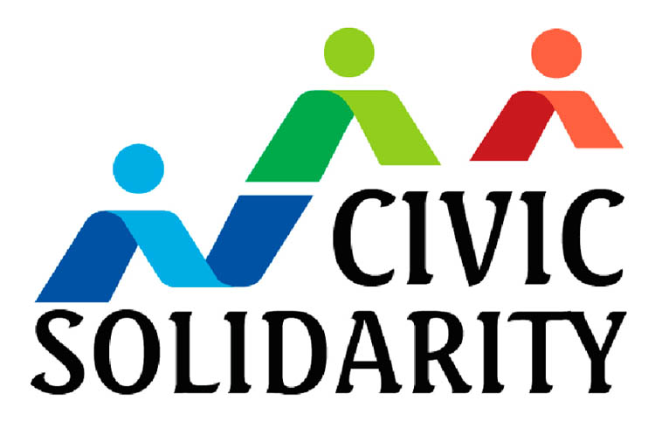

**CIVIC SOLIDARITY PLATFORM**

**STATEMENT**

**ADDRESSED TO THE INTERNATIONAL COMMUNITY AND THE PARLIAMENT OF AZERBAIJAN REPUBLIC**

**CALLING FOR THE RELEASE OF ACTIVISTS DETAINED FOR EXERCISING THEIR RIGHT TO PEACEFUL PROTEST**

**24 October 2012**

### We, the undersigned members of the Civic Solidarity Platform are alarmed to learn that, on 20 October 2012, police detained around 100 activists in Azerbaijan, to hinder a protest planned by youth movements and political parties. Protesters were also detained in the regions to prevent them from travelling to the protest in Baku.

### Protesters had gathered anyway at Fountain Square in Baku to call for the dissolution of the parliament, following the release of video footage showing that senior ministers and MPs in government had been involved in selling parliamentary seats.

### The video footage taken at the protest shows the police using excessive force to dispel the peaceful protestors. Although the Baku city mayoralty did not authorize the rally *per se*, the right to peaceful assembly comprises the right to protest by simple notification. The peaceful protestors did not disturb public order. Therefore, police should not have dispersed the demonstration and should certainly not have used force to do so.

### Following the breakup of the protest, 14 opposition activists were arrested and sentenced to administrative (misdemeanour) imprisonment terms, ranging from 7 to 10 days, for failing to obey police orders. Those arrested include former prisoners of conscience, Tural Abbasli, Rufat Hajibayli and Ahad Mammadli, who were previously sentenced from one and a half to two and a half years of imprisonment for taking part in protests on 2 April 2011, but later released by presidential pardon on 22 June 2012 following sustained international pressure in the run up to the Eurovision Song Contest which took place in Baku in May 2012.

### The same day people in ordinary clothes were unjustifiably detaining participants of a meeting of the opposition Musavat Party, held in the party’s headquarters. When exiting the building nearly 60 members of the party-were forcibly brought to police stations, 4 were sentenced between 7-10 days of detention, 26 were fined and the rest were released.

### We are deeply concerned about the Azerbaijani authorities’ *de facto* ban of demonstrations, which is in clear violation of Azerbaijan’s constitutional and international obligations to freedom of assembly and freedom of expression. Article 11 of the European Convention on Human Rights places obligations on the States to respect the right of freedom of assembly and to ensure in all circumstances that protesters are not subjected to ill-treatment.

### As a Council of Europe member, this crackdown on peaceful protest provides even more cause for concern. In January 2013, the Parliamentary Assembly of the Council of Europe (PACE) is due to review a report by its Monitoring Committee on Azerbaijan’s compliance with its accession commitments. The continued denial of the right to freedom of assembly in Azerbaijan is something that the Council of Europe should be monitoring very closely. The European Union – Azerbaijan human rights dialogue is currently being prepared and incidents such as this need to be included in it.

**In light of the recent events, we call on the Azerbaijani authorities to immediately release all those who were detained for exercising their fundamental democratic right to freedom of assembly and to put an end to the ban on demonstrations in the centre of the capital.**

In relation to the arrests, the Civic Solidarity Platform is also concerned about the proposed amendments to the Law on Freedom of Assembly, the Criminal Code and the Code of Administrative Violations which were proposed by MP Rafael Jabrayilov, who sent the draft to Parliament on 16 October. On 23 October, the parliamentary committee on legal policy and state building discussed the draft and it was recommend to the plenary session of Parliament for discussions and voting. According to these amendments the fines for organizers and participants of illegal demonstrations will increase, which is worryingly similar to the recent amendments to the legislation in the Russian Federation. Under the current legislation the fines are from 7 to 13 manat (approx. 7-13 EUR) for participation in an illegal demonstration. The proposed law would increase this to from 500 to 1000. If the organizer is an ordinary citizen the fine will be from 1500 to 3000, and from 3000 to 6000 if the organizer is an official. If the organiser is a legal entity (e.g. political party, NGO) then the fine will be from 15000 to 30000. These amendments prove once again that the government is interested in restricting, already week, freedom of assembly protection in the eve of the 2013 Presidential elections.

**We urge the Azerbaijani Parliament to vote against these amendments.**

 Albanian Helsinki Committee

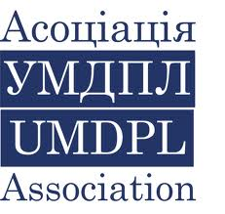 Association of Ukrainian monitors on Human Rights conduct in Law Enforcement (Ukraine)

 Analytical Center for Interethnic Comumnicaiton and Consultations

[Description: Home](http://belhelcom.org/en) Belarusian Helsinki Committee

[](http://humanrightshouse.org/) Belarusian Human Rights House in exile, Vilnius

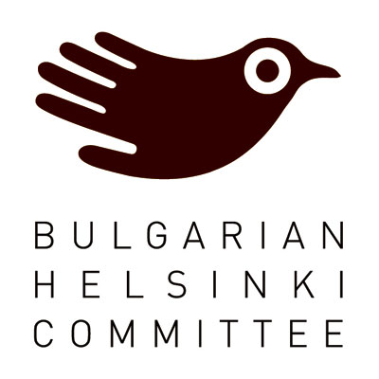 Bulgarian Helsinki Committee

 Centre for Civil Liberties (Ukraine)

 Centre for the Development of Democracy and

Human Rights (Russia)

Description: Center for National and International Studies Center for National and International Studies (CNIS), Baku, Azerbaijan

 Crude Accountability

Freedom Files Freedom Files (Russia)

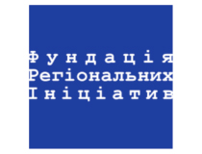 Foundation for Regional Initiatives (Ukraine)

 Georgian Young Lawyers’ Association

 Helsinki Citizen’s Assembly – Vanadzor (Armenia)

 Helsinki Foundation for Human Rights (Poland)

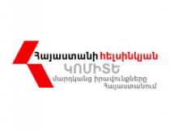 Helsinki Committee of Armenia

Human Rights Centre of Azerbaijan

 Human Rights House Foundation (Norway)

 Human Rights Monitoring Institute (Lithuania)

 Helsinki Committee for Human Rights (Serbia)

 Index on Censorship

 Institute for Reporters’ Freedom and Safety (Azerbaijan)

 International Partnership for Human Rights (Belgium)

 Kazakhstan International Bureau for Human Rights

 Legal Transformation Centre

Description: http://www.mhg.ru/img/logo.jpg Moscow Helsinki Group

 Norwegian Helsinki Committee

 Nota Bene (Tajikistan)

[Description: Promo-Lex ONG](http://promolex.md/index.php) Promo LEX Association (Moldova)

 Public Verdict Foundation

[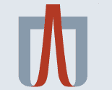](http://helsinki.org.ua/en/index.php) Ukrainian Helsinki Human Rights Union