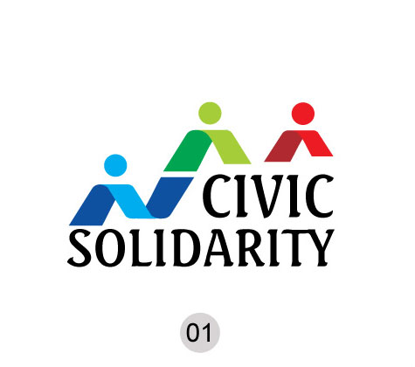

**An Update on Russia’s Foreign Agents’ Legislation**

*The Civic Solidarity Platform - a network of nongovernment organizations committed to improving the human rights situation in Europe, Eurasia and the United States - has repeatedly called on the Russian authorities to repeal the so-called Foreign Agents’ law, which requires any organisation receiving foreign funding and engaging in ill-defined "political activities" to register as a foreign agent. This law clearly contradicts Russia´s international human rights obligations.*

On November 18, a judge in Moscow agreed to a request by attorneys for four NGOs accused of violating the law – the Public Verdict Foundation, Golos, Jurix and the Human Rights Center Memorial – to adjourn hearings in their cases until early in the New Year. A hearing on a complaint against a fifth NGO, the Movement for Human Rights, was postponed to November 27, 2013. The lawyers had argued for an adjournment until after a pending a judgment on the matter from the European Court of Human Rights (ECtHR) in Strasbourg. Russia´s Constitutional Court is also considering the constitutionality of the law. If found guilty of failing to comply with the law, these internationally-renowned human rights organizations could face large fines, suspension of their operations and even prison terms of up to two years for their leaders.

In spite of the international outcry sparked by the passage of the Foreign Agents’ law, Natalia Taubina, Director of the Public Verdict Foundation, said after this week’s court decision that she "seriously doubts" that the Russia´s government will amend the law unless the ECtHR or the Constitutional Court rules that it violates the requirements of the European Convention and/or Russia’s Constitution. Her organisation is one of hundreds of Russian NGOs that were subjected early this year to an unprecedented campaign of government inspections. As a result of these inspections, three NGOs have been closed down and at least 80 organisations received warnings or orders from prosecutors’ offices to register as foreign agents due to their work on issues such as the transparency of elections, monitoring human rights violations and discrimination against lesbians and gays.

Taubina said Public Verdict "absolutely disagreed" with both the inspections and subsequent "illegal" actions and decisions of the prosecutors’ office against NGOs. Uncertainty related to the outcome of the ongoing legal proceedings against Public Verdict is affecting the organiation’s everyday work, Taubina said, adding that: "It is quite difficult to think about the organization’s long-term strategy and plan activities for the year if you do not know what the situation will be in a few months. Taubina said the "foreign agents" legislation has definitely affected Russian civil society at different levels, including taking disproportionate resources from normal NGO work to actions aimed at protecting the NGOs themselves.

The Brussels-based International Partnership for Human Rights (IPHR), a member of the Civic Solidarity Platform, is currently monitoring the trials of Russian NGOs charged under the Foreign Agents’ law and one of its monitors was present at Monday´s hearing in Moscow.

Roemer Lemaitre, a Belgian human rights lawyer, said the interim ruling by the Moscow court to await the outcome the Russian Ombudsman for Human Rights’ appeal to the Constitutional Court against the foreign agents’ law was a "positive" development. "However,” he added, “it’s difficult to grasp why at the same time trials in other parts of Russia are continuing. In St Petersburg a court earlier explicitly rejected a request for a delay." Lemaitre said that court hearings he had attended in St Petersburg and Moscow "generally" corresponded to international fair trial standards but that the Foreign Agents’ legislation contradicts Russia’s international obligations. According to Lemaitre, “The use of the term ‘foreign agent’ – which in Russian is a synonym for ‘spy’ – is irreconcilable with standards for freedom of expression and freedom of association enshrined in the ECHR." The law also violates the ECHR’s provisions against discriminatory treatment by punishing NGOs solely on the basis of the source of their funding.

This situation can only be remedied by repealing or substantially revising the Foreign Agents’ law so as to create an environment that enables individuals, groups and associations to freely carry out activities to promote and protect human rights and fundamental freedoms without any restrictions other than those authorized by international human rights treaties to which Russia is a party.

For more information please contact:

*Simon Papuashvili*

[*sp@iphronline.org*](mailto:sp@iphronline.org)

*+32494753942*