Human Rights Centre “Memorial”
The Bankrupt Referendum Findings of a monitoring mission to the Donetsk region of Ukraine
May 2014

Report Outline

Human Rights Centre “Memorial” 1
The Bankrupt Referendum 1

1. Human rights violations resulting from the actions of the supporters of the “People’s Republic of Donetsk” 3
1.1. Abduction of civilians and cruel treatment of the abducted 3
1.2. Violence against civil society activists 11
1.3. Possibility of peaceful assembly 13
1.3. Situation of the Mass Media 17

2. Civilian casualties during anti-terrorist operations 18
2.1. Ukrainian involvement in anti-terrorist operations in the Donetsk region 18
2.2. Events in Mariupol on May 9th, 2014 19
2.3. Events in Krasnoarmeysk, May 11th, 2014 23
2.4. Kramatorsk 24

3. “Referendum” of May 11th, 2014 27
3.1. Questions related the legitimacy of the referendum 27
3.2. Violations during the preliminary stages (prior to voting day) 28
3.3. Organizational and voting irregularities on the day of the referendum 29
3.4. Vote Counting 30
3.5. Conclusions 31

Human Rights Centre “Memorial”

The Bankrupt Referendum

Findings of a monitoring mission to the Donetsk region of Ukraine
May 2014

This mission was carried out with the support of the international Civic Solidarity Platform

From the 6th to the 16th of May, 2014, Oleg Orlov and Yan Rachinski of the Human Rights Centre “Memorial”, participated in a monitoring mission on the territory of Ukraine. The purpose of this mission was to gather information about the human rights situation in the Donetsk region before, during and after the so-called referendum on the future of the self-proclaimed “People’s Republic of Donetsk” and to monitor the referendum process itself.

The mission was carried out in the cities of Donetsk, Druzhkova, Konstantinovka, Kramatorsk, Mariupol and Kiev. The mission members interviewed civil society activists, government representatives, individuals effected by violence and witnesses. Additionally, the mission members closely monitored internet and video resources related to the events in order to compare them to the information gathered on the ground.

We are grateful for the assistance of the residents of Donbass who helped us in our work despite difficult conditions and we would like to thank the Center for Civil Liberties.

Key findings for the mission include the following:
1) Authorities and activists of the so-called People's Republic of Donetsk grossly and systematically violate human rights.
2) The referendum of May 11, 2014 cannot be considered legitimate. The methods used rule out the possibility of reliably determining its results.
3) Ukrainian authorities must urgently restore order within their internal power structures in order to completely eliminate the possibility of dispatching too few and poorly equipped fighters in places where they may clash with hostile civilians.
4) The Ukrainian authorities are obliged to suppress the activities of all illegal armed groups, including those positioning themselves as defenders of Ukrainian statehood. Self-appointed militias supporting Ukrainian statehood can cause just as much damage as the activity of separatists.

Human rights violations resulting from the actions of the supporters of the “People’s Republic of Donetsk”

Abduction of civilians and cruel treatment of the abducted
In the weeks preceding the referendum on the independence of the breakaway People’s Republic of Donetsk (PRD), the practice of kidnapping those who did not support the referendum increased. Some abductees were taken to the regional administration building which was occupied by PRD supporters and, as is well known, were detained and interrogated on the fifth floor. Some of those abducted were taken to other buildings occupied by supporters of the PRD. In some cases, those abducted disappeared and their whereabouts are still unknown. Bodies of several abductees were later found bearing signs of a violent death.

We can assume that these kidnappings were committed for several different reasons: to obtain information about those suspected of supporting the opposition; for the purpose of exchanging those captured for detained supporters of the PRD; for ransom, etc. Moreover, it is quite obvious that this practice is made in pursuit of an overarching goal – to intimidate opponents of the PRD. This goal has generally been achieved, as most of the active supporters of Ukrainian unity have either left the region of Donetsk, have gone into hiding or have suspended their legal activities. Civil society is largely paralyzed. As a result, many supporters of Ukrainian unity in Donetsk have been forced to admit that there remains no way to stand up for their ideals other than an armed struggle. Some of these people are located outside of the Donetsk region and are structured in “battalions” such as “Donbass”, “Azov” and “Dnepr”.

One of the leaders of the PRD with whom mission members were able to speak did not deny that a few dozen people captured in recent weeks have been held on the fifth floor of the regional administration building. He also did not deny that these people were subjected to physical and psychological violence and attempted to justify these actions by claiming that “everyone else is doing it.” According to this person, individuals were captured for the objectives of a) obtaining information; b) exchange with pro-PRD detainees; c) re-education/conversion. Containing a large number of forcibly detained people in the regional administration building for a long period would be difficult. Therefore, a number of people subjected to “re-education” were released, others were immediately exchanged and the rest were transferred to other locations intended to confine forcibly detained people.

We were informed that there were also illegal abductions and detentions of supporters of the PRD by representatives or supporters of the Kiev authorities. However, it has proven impossible to obtain any concrete information from PRD supporters. We have identified a specific person who was responsible for gathering information about human rights violations by the Kiev authorities in the Donetsk region. However, this individual was occupied with other tasks and was not able to provide us with information. We attempted to interview PRD activist Evgeni Potapov who claimed to have been abducted, taken out of the Donetsk region and held against his will. However, every time we tried to speak with him, he claimed to be busy or did not answer the phone.

Several kidnapping cases in the Donetsk region are described below. These are illustrative examples and do not constitute an exhaustive list of cases.
***
Six individuals were kidnapped during the day on May 4th, 2014 in Novogrodovka (a town located 45 kilometers north-west of Donetsk). They included two miners who worked in the “Russia” mine and were activists of the Independent Trade Union of Miners, Alexander Vovk and Alexander Gurov, deputies of the Novogrodovka city council Valeri Pavlik (Party of Regions), Oleg Bubich (Communist Party of Ukraine), Konstantin Museyko (Defenders of the Motherland Party) and another young man whose name will remain undisclosed.

The abductees all held a pro-Ukrainian position and some of them had previously obstructed the hanging of the PRD flag from the city council building. When visiting Kiev, we were able to interview Konstantin Museyko and Alexander Gurov. Their story painted the following picture.

On the day of their abduction, all six men were gathered in the courtyard of Museyko’s home to discuss the possibility of further actions to “resist the separatists”. No one was in the house apart from them as the owner had previously moved his family out of the Donetsk region.

Suddenly, ten people armed with Kalashnikovs burst through the fence into the courtyard. Seven of them were wearing uniforms of the special police forces of Ukraine “Griffon”, three wore camouflage uniforms (according to the respondents, these three were natives of the Northern Caucasus). The intruders immediately began shooting – they killed dogs and the home owner and his five companions laid face down on the ground. The armed men then entered the house and shot the ceiling, floor, mirrors, furniture and audio/video equipment. They took money and gold jewelry from the house and demanded to see documents related to Museyko’s business. During this time, Konstantin Museyko received a gunshot wound to the thigh. All six men were then thrown into a vehicle belonging to Museyko and, accompanied by several passenger cars, were taken to Donetsk. En route, Alexander Gurov managed to jump from the moving van, but he was unable to escape as the kidnappers opened fire with their machine guns and he was forced to lie on the ground. Gurov was beaten with rifle butts and thrown into a passenger car that followed the minibus to Donetsk.

At the entrance of the regional administration building their heads were covered by their own clothes and they were led up the stairs to a higher floor (Gurov estimated it to be the 4th or 5th, Museyko thought it was the 5th or 6th). There the abductees were taken to separate rooms, their heads were uncovered and they began to be interrogated and beaten. Some of the people beating and interrogating the abductees were wearing masks while others had their faces visible. They ripped a gold chain from Alexander Gurov’s neck and removed a signet ring from his finger. This was done by a man whose face was not covered and who, according to Gurov, was a resident of the North Caucasus. The interrogators found a tattoo on Gurov’s upper arm depicting the state emblem of Ukraine and the words, “Glory to Ukraine – Glory to the Heros!” The man began to cut his arm, explaining that he was “removing” the tattoo. As he was being moved to a different room, Gurov saw a badly beaten Vovk.

During the interrogation the abductees were asked questions about their connections to the “Right Sector”, about how much money was spent on their activities against the PRD and by whom, whether or not they were aware of the “Dnepr” and “Donbass” battalions, who finances their activities and how, etc. As they were being asked questions, they were punched in the face and kicked and clubbed in the body. The man interrogating Gurov hit him in the head with the handle of a pistol.

Gurov and Museyko are sure that the interrogators were professionals – they showed them professionally compiled documentation of the interrogations of others.

At some point, the detainees were taken to a medical center located in the same building. There the bullet was removed from Museyko’s hip and Gurov received some kind of injection after which he said his “legs became cotton and his head became heavy.” The questioning then recommenced.

Late in the evening on the same day, the abductees were moved to the TV and radio broadcasting center in Donetsk which was also occupied by PRD activists. They were handcuffed to chairs and kept all night. They were occasionally beaten and subjected to psychological pressure. The captors threatened to shoot them, cut their feet, etc. Museyko was told that his only chance for survival was to transfer his business to someone else. However, in this building they were beaten less than they had been in the regional administration building. They were allowed to go to the bathroom in the morning, they were given water and some of the guards even gave them a cigarette.

Gurov stated that in the TV and radio center he saw a detained Nikolai Yakubovich who had been kidnapped previously.

On the morning of the 5th of May, five of the abductees, Alexander Vovk, Alexander Gurov, Valeri Pavlik, Oleg Bubich and Konstantin Museyko were released. First were Bubich, Vovk and Pavlik, followed by Gurov and Museyko. The freed men were put into ambulances and transferred to the city hospital where they received medical assistance and were then reunited with their relatives.

We do not know whether the abductees were released in exchange for detained PRD supporters, or whether their release was a result of the increased reporting on abductions in Ukrainian and foreign media which has drawn the attention of international institutions (such as the UN mission and the OSCE). It is possible, however, that the main goal of the captors was to intimidate their opponents and force them to leave the Donetsk region.

On the same day, all five men travelled to Kiev. There, Vovk and Gurov spoke about their experience at a press conference.
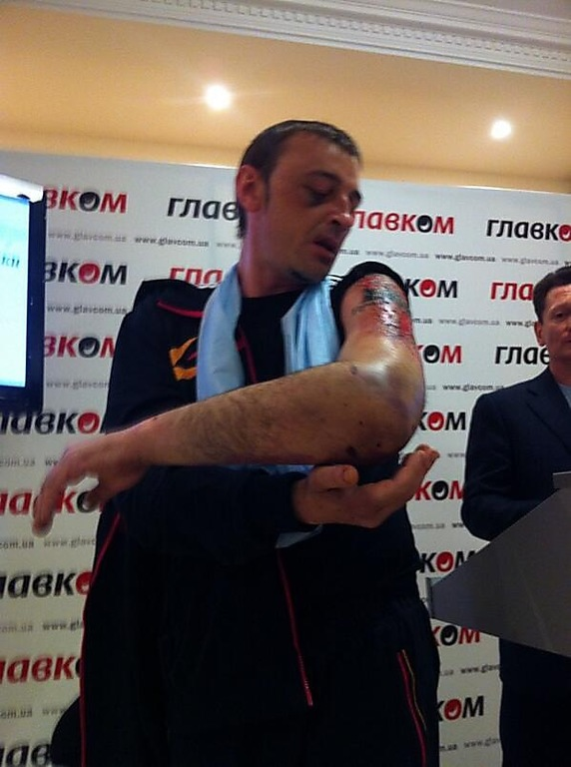
Alexander Gurov at a press conference

All five men are facing a long recovery process. As a result of the torture and beatings, Konstantin Museyko suffered three broken ribs and a broken nose. He had seven bruises across his face and doctors documented injuries to his chest and back. As of May 16th, he has no movement in his right hand. Alexander Gurov suffered two broken ribs and a broken nose. He had to have surgery on his elbow and hand which were damaged during the beatings and his upper arm is healing slowly. Alek Bubich suffered two broken ribs and Valeri Pavlik received a head injury. The following photo of Alexander Bubich clearly shows the results of the treatment given to those abducted and held within the regional administration building.
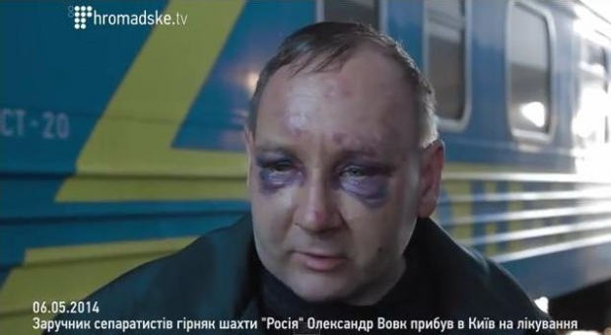
***
Around 11:30 am on May 8th, in Makeyevka, a group of armed men broke into the home of Alexander Demko, the authorized representative of the Ukrainian presidential candidate of the “Svoboda” party, Oleg Tyagniboka. Demko was beaten and taken away to an unknown location. This is known because Demko, seeing the armed men through his window, called his friend Pavel Derkachenko, informed him of what was happening and laid the phone down in the room, with Derkachenko still on the line. Derkachenko could therefore hear everything that was happening. He heard the intruders demand that Demko confess to having links with the “right sector” and subversive activities against the supporters of the PRD and to provide the names and addresses of other members of the “Svoboda” party. He heard what sounded like blows, smashing furniture and breaking dishes. Then someone said, “If you don’t want to speak, we will quickly untie your tongue on the fifth floor.” By this, they apparently meant the fifth floor of the regional administration building in Donetsk.

Upon receiving information about this event, one of the few remaining social activists in Donetsk engaging in human rights work (whose name has been withheld for security reasons) informed the regional police chief K. Pozhidaev about the crime. The same day, the activist called the Makeyevka police and discovered that Demko was in the miners’ hospital in Makeyevka. He suffered from physical trauma – a piece of metal was found in his stomach during an operation which no one could recognize. However, according to unofficial information from the doctors, Demko had a bullet wound in his stomach.

The next day, doctors tried to move Demko outside of the Donetsk region due to security concerns. Demko was taken in an ambulance and accompanied by a doctor named Galina Ivanova. However, the car never arrived in Dnepropetrovsk. Later, an empty car with bullet holes was found on the bypass road between Donetsk and Makeyevka. The fate of Alexander Demko, Galina Ivanova and the driver is not known.
***
On April 28th, after supporters of the PRD violently dispersed a “March for United Ukraine” in Donetsk, six students who participated in the march were captured by unidentified armed men.

On the evening of April 28th, six young people (four students of Donetsk National University, one vocational school student and one apprentice college student) were sitting in the yard of a house near the venue of the march, drinking beer and discussing the day’s events. At around 10:00 pm, a group of armed men entered the yard, searched the students and forced them to undress. In their pockets they found blue and yellow ribbons sported by proponents of a united Ukraine and discovered some tattoos of Ukrainian symbolism. A minibus drove into the yard and headed for the young people. One of the six managed to escape and ran away. Thanks to him, others were alerted to the abduction of the five young people.

In discussion with the mission members, one of the leaders of the PRD movement claimed that the students were detained due to the supposed presence of swastika tattoos which the captors took as an indication that they were involved with the “Right Sector” and should therefore be interrogated.

The five young men were taken to the fifth floor of the regional administration building and were beaten in order to obtain confessions of their involvement with the “Right Sector”. They were beaten with fists, rifle butts and one student had a gun pointed at his chest and was told that he would be shot immediately. As a result of this treatment, some of the students were forced to make partial “confessions” which were captured on video. It was claimed that the captured students were found with weapons – laying on the floor next to the seated students were guns that had allegedly been discovered in the student’s possession (VIDEO AVAILABLE ONLINE).

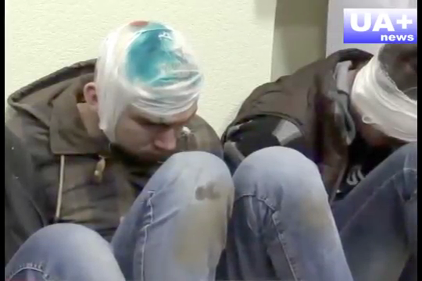

Immediately upon learning of the abduction of the young people, activists of the “March for United Ukraine”, human rights activists and the students’ parents appealed to the police, the city administration and the UN observation mission in Donetsk. As a result, at four o’clock in the morning on April 29th, all five students were released, taken to the police department and then transferred to the hospital. The condition of the freed youths was grave. One of them had two broken ribs, another had a broken nose, two had head injuries and one had a broken arm.

The next day, during a press conference, the head of the administration of Donetsk, Alexander Lukyanchenko, stated, “With regard to the five hostages who were captured by supporters of federalization, they were released after lengthy negotiation.” (VIDEO AVAILABLE ONLINE)

Participants in these negotiations told the mission representatives that securing the release of the five students was challenging not only because they were captured by supporters of the PRD, but because several others did not want the release of “fascists”.

After their liberation, the students were not left in peace. They learned that some supporters of the PRD were still looking for them because they believed they had not fully “understood” the students. Additionally, they were sought by police officers who insisted that they retract statements they had made demanding criminal charges against those who kidnapped and beat them. As a result, they were forced to write an application to retract their previous testimony and then they left Donetsk.
***
On May 2nd, Nicolai Yakubovich, a retired policeman who had moved to Donetsk from Brest (Belarus), was kidnapped. During the standoff on the Maidan in Kiev, he had commanded hundreds of self-defense protestors. Later he became an advisor to the Secretary of National Security and Defense of Ukraine, Andrei Parubiya, and led supporters of a unified Ukraine in Donetsk. According to media reports, he said that “his people are ready to wage a guerrilla war against the militias of the PRD.”

Right before his abduction, Yakubovich headed to an appointment he had with someone outside of the McDonald’s restaurant. In front of witnesses, a group of armed men arrived in a Jeep and shot at the car containing Yakubovich, injuring him. Yakubovich was then thrown into the car and driven to an unknown location.

It later became known that he was being held on the fifth floor of the regional administration building occupied by supporters of the PRD. There he was interrogated and tortured. He was later transferred to the TV and radio broadcasting center and subsequently released on May 6th, apparently in exchange for the release of detained supporters of the PRD.

On May 5th, a video was posted online (VIDEO) featuring a masked man with a PRD flag in the background proclaiming that, “responsibility for the capture of the anti-terrorist operation coordinator in Donbass takes on the Russian Orthodox army.”
Yakubovich then appears briefly; the condition of his face and head leaving no doubt that he had been beaten.
***
Supporters of the PRD are seeking to establish control over mines in the Donetsk region. Apparently, this was the cause for the abduction of the Director General of the state association “Artyomugol”, Nicholas Alysheva, on May 5th in Gorlovk (45 kilometers north of Donetsk). A group of armed PRD militants seized him and his manager of Social Affairs, Edward Nanarov, at their workplace. They were taken to the building of the Gorlovka Department of the Interior which had been occupied by PDR supporters. There they were severely beaten, and Alysheva was forced to sign a document declaring the resignation of four mine directors. As a result of their treatment, Alysheva’s jaw was fractured and he had trauma to the head and spine. Both of the kidnapped men were released on May 6th. There are unverified reports that a ransom was paid to secure Alysheva’s release.
***
During the day on May 7th, in the village Shandrigolovo in the Krasnoliamansk district, local farmer Valeri Salo was kidnapped in front of witnesses. His car, which was in the center of the village, was blocked by armed men who arrived in several cars. They pulled Salo out of his vehicle, beat him and threw him in the trunk. One of the armed men got behind the wheel and drove off in the direction of the Lugansk region.

The next day, on May 8th, in the Grekovskaya forest near the administrative border of three regions – Lugansk, Donetsk and Kharkov – policemen found a burned out car with the body of a man inside. The body and the car were taken to the Lugansk region where, upon examination, it was determined that the body was that of V.V. Salo and the car had been registered to him. A criminal case has been lodged.

Valeri Salo was a supporter of a unified Ukraine and an active member of the cultural and educational NGO “Enlightenment”, which promotes and develops Ukrainian culture.
***
On April 19th in Kostiantynivka (60 kilometers north of Donetsk), armed men abducted 42-year-old Yaroslav Malanciuc, a member of the District Electoral Commission from the “Svoboda” party. In front of witnesses, he was seized on the street near a shopping center, forced to his knees, bound and thrown in a car which drove off to an unknown location.
According to unconfirmed reports, Malanciuc is currently being held in the basement of the Ukrainian Security Service in Slavyansk which is occupied by PRD supporters.
***
On the night of April 30th to May 1st, the leader of the local branch of the “Svoboda” party, Artyom Popik (born in 1988) was kidnapped in Kostiantynivka.

Mission representatives from HRC “Memorial” interviewed Popik’s mother, Lubov Nikolaeva Popik, who stated the following:

Around 12 o’clock at night, Artyom was smoking in the yard of their private home. Suddenly, he ran into the house clutching his face and shouting “Follow me! Come!” He managed to slam the door to the house and told his mother that he had been hit in the face by a tear gas can. At that moment the door started to be broken down. It soon gave way and tree people burst in – two men in masks, camouflage and holding a gun and a pistol, and the third in civilian clothes without a mask or weapons. While the attackers had been breaking down the door, Artyom Popik was able to call someone and inform them of what was happening and then dialed the police to ask for help. He tried to hide and climbed under the bed, but one of the men turned the bed over and pulled him out by the collar. They threw him on the floor, held his hands behind his back and handcuffed him. They took him barefoot out to the street and threw him into the trunk of a car that was parked in front of the Popiks’ gate. When his mother asked, “Where are you taking him?” they responded “to be brainwashed.”

The car containing Popik drove off. Fifteen minutes later the police came to the house. They interviewed Popik’s mother, examined the crime scene and made a report. However, the police did not attempt to pursue the kidnappers.

At the moment, a criminal investigation into the abduction has been launched. The fate and whereabouts of Artyom Popik are not known. There is some information that A. Popik is being held by PRD supporters in the basement of the Ukrainian Security Service building in Slavyansk.
***
On May 9th and 10th relatives of 20-year-old EuroMaidan participant and member of the “Svoboda” party, Yuri Benedyuka were taken from his home in the suburbs of Makeyevki.

Yuri Benedyuk, fearing for his safety, left the Donetsk region. However, he was extremely active on social media, occasionally posting offensive remarks about supporters of the PRD. It is possible that this triggered the incident with his relatives.

On May 9th in Buroz (in the Khanzhonkov town of Makeyevki), policemen and several representatives of the PRD came to the house of Yuri Benedyuka’s mother and step-father, Elena Benedyuk and Yuri Myacoed. They were looking for Yuri, but unable to find him, they apprehended his step-father, claiming that he had participated in a drunken brawl.

The next day, members of the PRD arrived, unaccompanied by police, to another apartment where Yuri Benedyuk was registered. At the time, Yuri’s mother and several other relatives were in the apartment. The members of the militiamen declared that they were taking his mother hostage. They then called Yuri on his cell phone and demanded that he present himself to them.

Information about the incident quickly spread across Ukrainian media and publications. Later it was reported that Yuri received a phone call from an unknown number, demanding a ransom of the release of his relatives in the amount of one hundred thousand dollars.

However, on May 12, Elena Benedyuk and Yuri Myasoed were returned home, as reported by Yuri Benedyuk himself. Some Ukrainian journalists have questioned the veracity of this story. During the mission, we ourselves were unable to determine the authenticity of these claims.

However, a clip posted online by supporters of the PRD on the evening of May 11th, the day of the referendum, convinces us that Elena Benedyuk and Yuri Myacoed were indeed forcibly taken from their home and were held in the City Council building of Makeyevki which is occupied by PRD supporters.

The creators of the clip sought to refute the widely broadcast information about the capture of the two hostages in Makeyevka, but instead managed to produce strongly self-incriminating material. (VIDEO)

In the clip, a husband and wife are shown not to be in their house, but rather in the occupied City Council building and are answering questions posed by an unknown person.

- “Yesterday, the media reported that you were taken hostage. What would you say?”
Yuri Myacoed: “That didn’t happen to us. On the contrary, we were being guarded so that we could move from Donetsk oblast to Dnepropetrovsk. <…> I think it is because of my stepson who is in the “Svoboda” party.”
- “How do you feel here?”
Yuri Myacoed and Elena Benedyuk: “Good. There are doctors here and they fed us and gave us tea.”
“Have you been here before?” “No” “Where did you get that black eye from?”
Yuri Myacoed: “It’s part of everyday life”
“How do you feel about the political activities of your son?”
Yuri Myacoed and Elena Benedyuk: “Bad”. <…>
“Are you going to vote in the referendum?”
Yuri Myacoed and Elena Benedyuk: “Of course”
“What do you think about the political situation in the country?”
Yuri Myacoed: “I think that we would be better off joining Russia.

This was followed by footage of Yuri Myacoed and Elena Benedyuk going to vote. The voting took place on the street, there are no voter lists and data from their passports is entered onto blank sheets lying in front a worker. Upon receiving their ballots, both immediately open them (apparently there are no booths), put a tick and cast their ballots in the ballot box standing on the table where they are issuing ballots.
***
It is not only the opponents of PRD that are kidnapped, but also activists within the PRD structure itself. Apparently, the reason for this is the internal conflicts between supporters of the PRD. An example is the attempted kidnapping of Edward Akulov, the commander of a formation calling itself “the Eastern Front”. He was captured and beaten on April 13th in Makeyeva (a city adjacent to Donetsk to the north-east).

Akulov (who is retired and engaged in small business endeavors), told members of the mission from HRC “Memorial” that the “Eastern Front” which he leads, includes residents of the Donetsk region who support the idea of creating an independent PRD. According to him, it is the “Eastern Front” that pushed him to become the “Commissioner” of the formation as a deputy to the PRD. Some friction arose between the “Eastern Front” and local criminal gangs who tried to enter into the formation and immediately started a call to take up arms. However, Akulov and its Commissariat viewed the goal of the “Eastern Front” in a different way. “First of all, we want to work with the masses and get the support of the population. If we immediately take up arms, then we are just thugs.” According to Akulov, he was not interested in participating in criminal activities. Afterwards, the leadership of the “Eastern Front” had to expel members who showed a lack of discipline and a penchant for looting.

On April 13th, around 9:30 pm, Eduard Akulov learned that a crowd had stormed the Makeyevka City Council building and he met with several of his subordinates from the “Eastern Front” nearby, since he felt it was important to be aware of what was happening. There, he was attacked by a dozen unarmed people in masks. During the abduction they shouted that they were law enforcement officers of the PRD and that they were carrying out the detention of those suspected of having links to the “Right Sector”. Akulov was thrown into a nearby parked car and driven to the outskirts of Makeyevka, where he was then beaten. One of the kidnappers took off his mask and Akulov recognized him as one of the former members of the “Eastern Front” who had been kicked out for a lack of discipline and calling for looting. Two other well-known criminal authorities were also there who said, “We offered to interact with you, but you refused…” Akulov demanded to be released and told the kidnappers that they would not get away with such violence. In response, they stated that they intended to deliver him to the Donetsk regional administration building, occupied by PRD supporters and where their headquarters are located, saying, “there they will figure out what to do with him.” According to Akulov, a few days earlier an “unpleasant dispute” took place in the regional administration building and he feared that this dispute would continue and have a bad outcome for him if he were transferred to that building.

Nevertheless, the kidnappers loaded him into a car and drove towards Donetsk. Akulov suggested that they call one of the members of the PRD leadership, which they did. The person they called chastised the kidnappers. After this conversation, the kidnappers stopped the car for some time and deliberated among themselves what to do next. They then began to drive Akulov to a new location. At this point, due to the weakened control of the captors, Akulov was able to jump from the moving car and escape. However, he hit his head on the ground, receiving a head injury, and had to spend three weeks in the hospital.

Violence against civil society activists
In early May, in the village of Novoselovka in the Krasnolimansk area, there were two attacks on members of the Zaitsev family who live in the village.

Victor Zaitsev is a farmer and chairman of the local branch of the Ukrainian organization “Enlightenment”. This educational organization is dedicated to Ukrainian culture, language and history. His wife, Natalia Zaitseva, is a teacher of Ukrainian language and literature at the local school. The Zaitsevs’ son, Nicholas, is 24 years old.

On May 6th, at the school where Natalia Zaitseva works, one of her students came up to her with a Russian flag draped across his shoulders. Zaitseva made a remark to him that he should not wear such things to school; if a student wants to wear a Russian flag, they can do it outside of the classroom.

On the evening of the same day, the father of the student – an active supporter of the PRD who regularly helped his associates to create blockades and checkpoints - came to the Zaitsevs’ home. He called Natalia, who was home alone at the time, out to the street and proceeded to beat her. That evening, the Zaitsevs made a statement to the police about the crime. No investigation into the incident has been made.

At around 4:00 pm on May 8th, a jeep without license plates drove up to the Zaitsevs’ home. Three armed men got out and came into the yard. They were met by the owner of the home who had an axe in his hand and the dog jumped towards the men. They opened fire, hitting the dog and striking Victor Zaitsev in the ear. One of the men held the homeowner at gunpoint while the other two started to beat his wife saying, “This is for the ‘Glory of Ukraine’”, “This is for wrongly teaching our children”. The son tried to intervene to help his mother, but he was also beaten. The armed men entered the house and opened fire, shooting at the furniture, mirrors and dishes. They also smashed all the audio and video equipment. Finally, before leaving, the attackers threatened, “if you complain to anyone, our next visit will be the last.”

During these events the Zaitsevs’ neighbor tried to intervene, but was grazed by a bullet in the stomach.
***
During May, in the village of Alexceyev-Druzhkovka, there were two attacks on the home of a City Council deputy, business man and member of the “Enlightenment” organization, Evgeni A. Shapovalov.

On the night of the 3rd to the 4th of May, unknown people threw three bottles of flammable liquid into Shapovalov’s house. Fortunately, none of the bottles came through the window – perhaps the attackers had no such intent. Two crashed against the bring wall and the third fell into the courtyard where flames broke out which the homeowner was able to extinguish.

During the attack only Yevgeni, his wife and 3 ½ year old granddaughter were at home. The following day, the Shapovalov family left the Donetsk region. Five days later, on May 8th, an unmarked jeep drove up to the empty house. Three armed men marched into the courtyard and shot at the dog then tried to shoot the lock on the front door. Failing in this, they broke a window and got in. They went through the utility rooms, the basement and emerged with some items.

The Shapovalovs’ neighbors watched these events, after which they called the police and demanded that they file a report. The neighbors also reported on the phone what happened to Shapovalov.

When visiting Alekseyev-Druzhkovka, mission representatives of HRC “Memorial” drove to the house of Yevgeni Shapovalov and saw traces of the flammable liquid on the walls of the abandoned home. Neighbors confirmed the events described above.
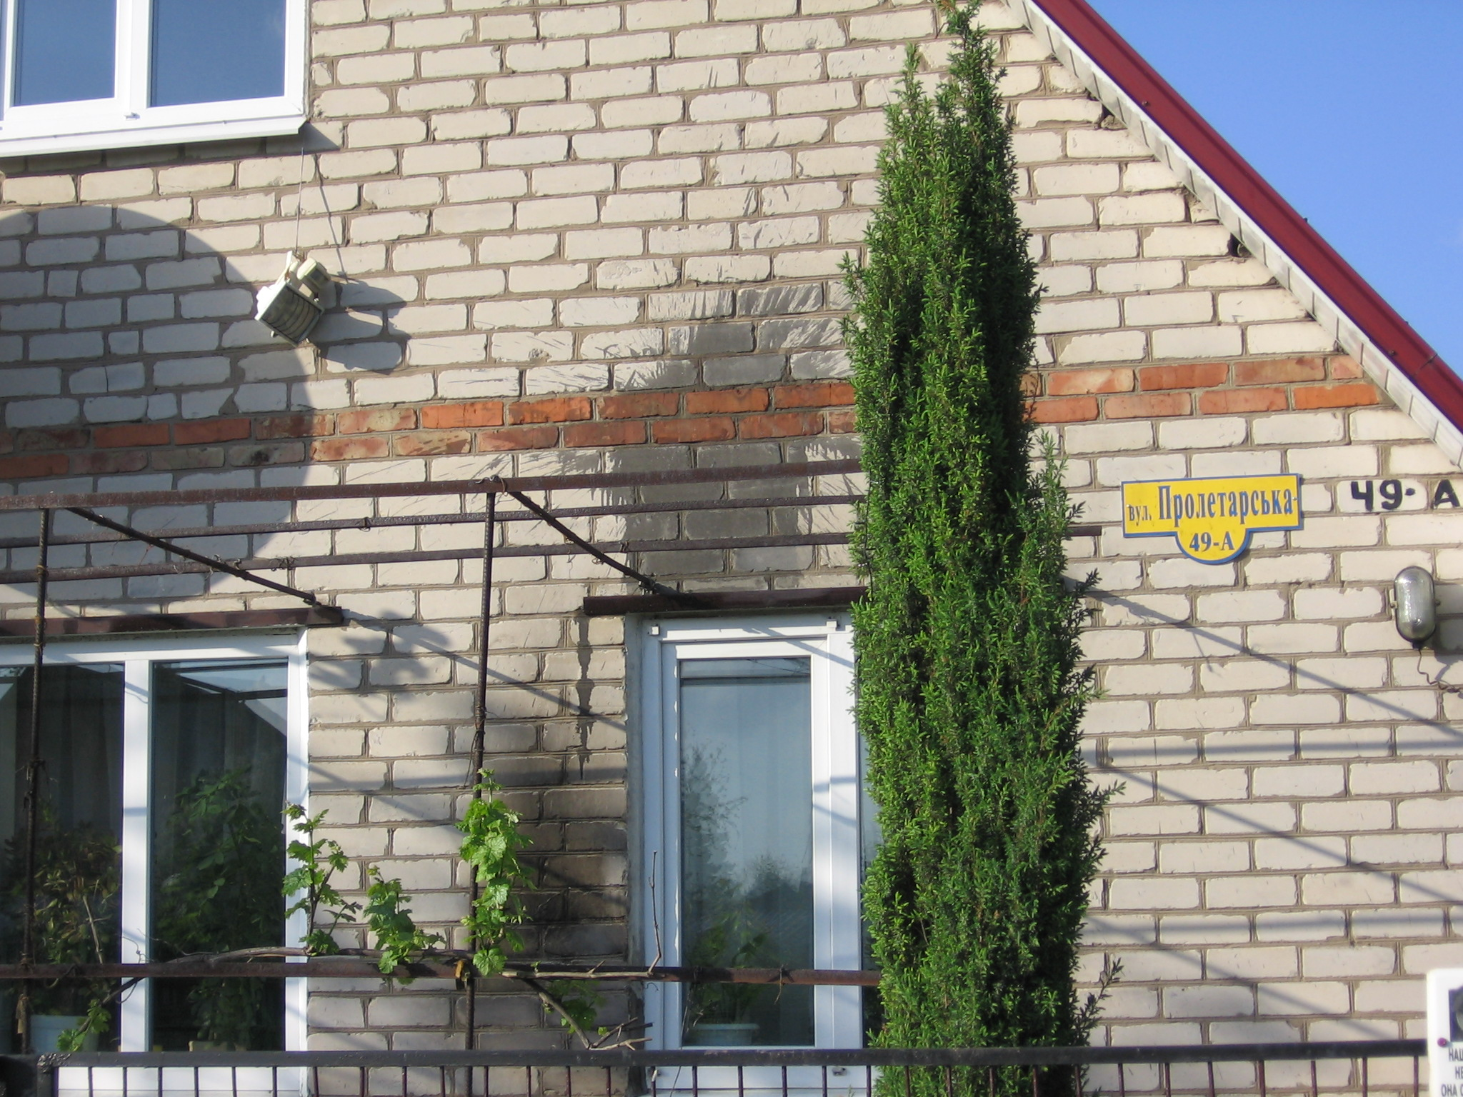
Shapovlev himself told the representatives of HRC “Memorial” that the only conflict between him and the PRD activists occurred on May 1st, when he “rudely” refused to pay three thousand hryvnia for the maintenance of a checkpoint located on a road leading out of Druzhkivka.

The following quote characterizes the educational activities in which Shapovalov was engaged: “A year ago, historians from several cities, including Kramatorsk, gathered at the Alekseyev-Druzhkovskaya library to discuss stories related to the establishment of the oldest settlement in the north of the Donetsk region. Exactly one year later, the history of Alekseyev-Druzhkovka came into being. Few expected the book to be so illuminating and impressive: more than 300 pages and full of interesting articles and photos. The lion’s share of the credit goes to Yevgeni Shapovalov, village council deputy and ethnographer, who not only initiated the creation of the history of Alekseyev-Druzhkovka and raised the funds necessary for its publication, but was also actively involved in writing portions of the work. Alekseyev-Druzhkovka is lucky to have such a patriot.”
***
On May 8th, after 10:00 pm, an Orthodox priest of the Mosocw Patriarchate named Father Pavel (Pavel V. Zhuchenko, born in 1970) was killed at the checkpoint installed by PRD supporters on the road leaving Druzhkovka.

At 10:45 pm ambulances arrived on the scene. Upon their arrival, the doctors found the body of the priest with a bullet wound not far from a passenger car. Those on duty at the post claimed that they were forced to shoot at the car which had driven quickly through the checkpoint without stopping, despite the order to do so.

Father Pavel had served for a long time in the Druzhkovka church and enjoyed great prestige, not only among his parishioners, but even among non-believers and other people in the small town. However, three months previously, due to some conflict among the church leadership, he was removed from the ministry. When social conflict started to increase in the region and began to erupt in episodes of armed confrontation, Father Pavel tried to begin a peacekeeping operation on his own initiative. He went to the armed men of the different factions – to the Ukrainian National Guard soldiers stationed in Slavyansk, to the Slavyansk militia, and to the checkpoints – and called for peace. Not everyone approved of his actions and those on duty must have recognized him and his car. It is known that on this day he had gone to Slavyansk where he had had a difficult conversation with the leadership of the militia.

The death of the priest resonated profoundly with the residents of Druzhkovka and Konstantinovka.

1.3. Possibility of peaceful assembly
Supporters of the PRD in Donetsk are able to carry out their demonstrations on the streets without impediment. They have continuously been making demonstrations in the streets, on Lenin Square and around the regional administration building where they set up tents, distribute leaflets and display posters, etc.

A rally and march in honor of Victory Day on May 9th in Donetsk’s Lenin Square, and in other cities in the regions, almost turned into an action of PRD supporters.

Opponents of the idea of an independent PRD have had no opportunity to exercise their right to peaceful assembly, either before the referendum or afterwards. A rally for a “United Ukraine” was repeatedly subject to violent attacks by PRD supporters. In Donetsk and Kiev, we interviewed a large number of participants in these events and carefully studied videos that had been posted online referring to what happened to the City Council Secretary of Donetsk. None of our interlocutors, including supporters of the PRD, have been able to provide a single example of a meeting or rally held by PRD supports that came under attack by opponents.
Here we will concentrate on the two largest collisions that occurred on March 13th and April 28th. During the conversation, which took place on May 7th in the city administration building of the Donetsk City Council Secretary, S.V. Bogachev, we recognized that in both cases the attackers were pro-Russian activists and also supporters of the PRD. However, our interviewee laid the blame for the tragic events on both sides since, in his view, the proponents of a unified Ukraine “provoked their opponents”.
***
Midway through March, supporters of a unified Ukraine gave advance notification to the authorities of Donetsk, in accordance with Ukrainian law, of their intention to hold a rally on March 13th in Lenin Square.

Two weeks previously, on March 1st, during a rally on Lenin Square in Donetsk, pro-Russian activists expressed their disagreement with the policies of the new Ukrainian authorities. They elected Pavel Gubaryov as the “People’s Governor” and temporarily seized the regional administration building. Supporters of a unified Ukraine therefore felt it necessary to express their opinion on the matter.

On March 9th, rally organizers held negotiations with the city police to discuss security issues. Two hundred and fifty policemen were allocated to maintain law and order at the rally. Representatives of the HRC “Memorial” were told by the organizers and participants of the meeting that there had been reports of possible provocations and attacks and that they formed their own “self-defense” force (about 100 people) and involved a few dozen football fans for additional security. These people were not armed and did not bring sticks or pipes. Some of them wore padding on their feet and hands, elbow pads, knee pads and other protective equipment. Some were in possession of tear gas canisters. All of these people were residents of the Donetsk region.

On March 12th, pro-Russian activists also filed a notice of their intention to hold a meeting on March 13th on Lenin Square. Obviously, this second rally was planned in order to disrupt that for a “united Ukraine”. Otherwise, there would be no clear explanation as to why they had to hold their rally at the same time and in the same Square.

As a result, that evening at 6:00 pm, two hostile rallies were held in the same space, separated by a thin line of police. The law enforcement forces were clearly insufficient. The local authorities, like the police and civilians, couldn’t help but think that tragic events would occur on the Square. Nevertheless, adequate preparations were not made.

According to various estimates, the rally for a “united Ukraine” was attended by several hundred to two thousand people. The pro-Russian rally was larger and more aggressive. In reality, it was not so much a rally as a gathering of people with the specific intent to inhibit the peaceful assembly of supporters of a unified Ukraine. This is demonstrated by video clips uploaded online: VIDEO (filmed by members of the pro-Russian rally) and VIDEO (filmed by members of the rally for a unified Ukraine).

The mission members interviewed some of those who were protesting for a unified Ukraine who described how they had potatoes, bottles, smoke bombs, firecrackers, bags of flour and stones thrown at them. Given the tense atmosphere, the organizers of the rally decided to disband earlier than scheduled and people began to disperse. According to plan, the members of the self-defense force would ensure the safe exit of the rally participants before leaving themselves. However, when most of the participants had already dispersed, pro-Russian rally participants broke through the police line. They surrounded the few members of the self-defense force who remained in the square (from a few dozen to a couple hundred). Apparently, the attackers accused them of being “Banderovki” who had come to Donetsk from other regions of Ukraine. A fierce fight broke out during which an activist from the Donetsk branch of the “Svoboda” party, Dmitri Cherniavski, was stabbed to death.
The most complete video footage VIDEO 1, VIDEO 2 further illustrates the events. The stories recorded by mission members correspond to what can be seen in the video clips posted online. A group of young people acting as the self-defense force for the rally for a unified Ukraine were surrounded by an extremely aggressive crowd. They had no bats or pipes, but a few of them did have tear gas cans. The police tried to protect them, but they were not very active. At one point, some of the pro-Ukrainian activists were put inside of a police van for protection.

What happened next was strange: the police actually opened up access to the van and it became a trap for those hiding inside. Stones crashed through the windows and the front of the van was packed with people. The van became over-crowded and people began to fall out. They were forced to kneel and some of them were beaten. The police were sluggish in trying to protect these people. It is not clear what put a stop to this episode and it is not explained in the video clips. Obviously, there was some sort of breakthrough, orchestrated either by the police or by pro-Ukrainian activists. In any case, many of those trapped were able to escape, but not all. As of this writing, dozens of people are still recovering in the hospital. VIDEO 1; VIDEO 2; VIDEO 3

Many Russian media outlets (for example, Rossiyskaya Gazeta” and the program “Vesti RTR”) reported that the bloody events in Donetsk were provoked by radical Ukrainian nationalists.
***
Over the course of the following days (March 15th, 16th and 17th) pro-Russian rallies hosted by PRD supporters were held in the city center (including Lenin Square) and went off without hindrance.

On the 17th of April, supporters of a unified Ukraine were still able to hold a rather large rally which was organized by different people than that of the 13th of March. The gathering took place outside of the city center, under heavy police guard and proceeded without incident.
***
On April 28th, supporters of a unified Ukraine decided to hold a rally and a march. They submitted a notice to the local authorities in advance and the organizers discussed the plan for the event with the city police. According to policy, the city should have provided around one thousand properly-equipped law enforcement officers.

Since the regional administration building in the city center had been occupied by PRD supporters by this time, the event organizers decided to avoid excessive risk and planned to hold the gathering a sufficient distance from the building and plan a procession route away from the city center.

During the day, an “Automaidan” event took place in Donetsk: a convoy of several dozen vehicles with Ukrainian flags drove through the city. However, this action was met with violence. Aggressive people armed with bats and iron bars stopped the column and seriously damaged eight cars.

At 6:00 pm, several thousand marchers gathered at the Olympic Stadium. After a short rally and the playing of the Ukrainian anthem, the participants marched down Artyom Street in the opposite direction of the regional administration building. As we were told by event participants (and which is confirmed by online video footage Watch here; VIDEO; Another recorded VIDEO), the march was peaceful and included many young and elderly people – some people even brought their children. None of the protestors were armed with sticks.

The back and sides of the demonstration were guarded by policemen in full riot gear – helmets, protective body armor, shields and batons. The column marched down Artyom Street for a kilometer when the organizers received information that the procession was being followed by a few hundred people with shields, batons and helmets. One of the organizers explained that, after receiving this information, he immediately turned to a police officer with whom he had previously spoken. The officer said that that they would “take all necessary measures.” Soon, however, explosions could be heard near the back of the column and people were screaming – a panic then broke out.

One of the participants of the event told us that he and his wife had missed the beginning of the march and had caught up with the rear of the column when they heard the sound of people running. He had only begun to turn around when he received several blows to the leg from a hard object. He fell and dislocated his arm. His leg injury proved so serious that by March 11th he could hardly walk and had to lean on a crutch. His wife reported that she saw the attackers strike an elderly, grey-haired man. He fell to the pavement and was bleeding from the head. She had called to a police officer while it was happening and demanded “Why aren’t you doing anything??”, to which he did not respond.
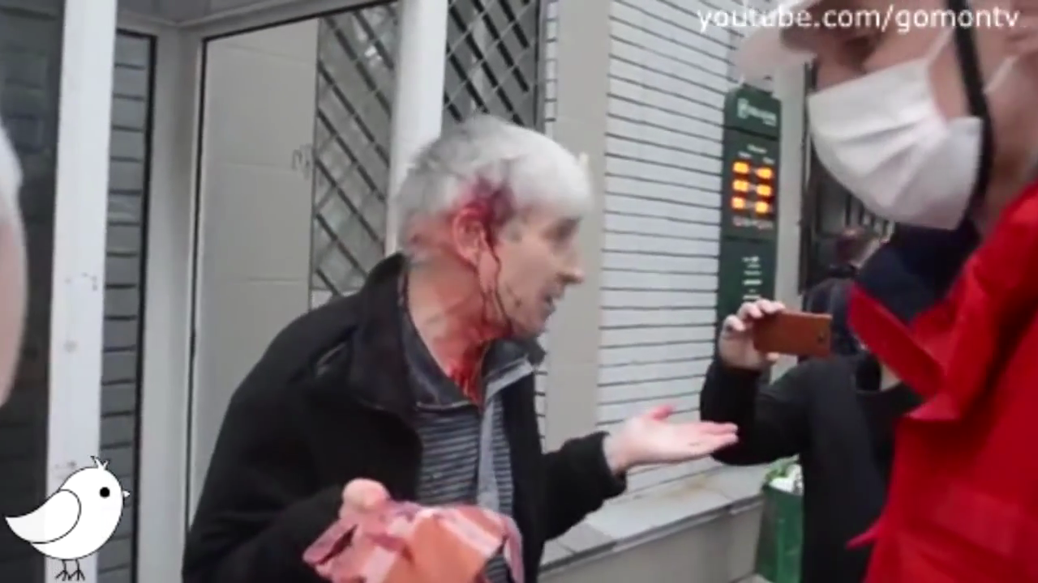

The attackers, many of whom wore St. George’s medals around their necks or sported the Russian tri-colored ribbons, ran ahead, lashing out at those with whom they caught up.

Participants in the event reported that the police guarding the demonstration did not even try to resist the attackers. Videos show that this was not entirely the case. The police put up a tacit resistance, creating a wall of shields that lined the street which the attackers avoided. There were constant orders “Do not attack the police!” and generally the fighters and police officers behaved neutrally against one another.

The rally began to be brutally disbanded. The attackers threw firecrackers which disoriented people and beat people with iron pipes and bats, even those lying on the ground.

Videos posted online show that the line of attackers was formed in front of the occupied regional administration building and cries of “Russia!” and “Well done!” could be heard among the assembled crowd after the announcement of a “successfully completed operation” (VIDEO 1; VIDEO 2).

When the procession had been dispersed, the attackers began to comb the nearby yards, catching and beating those who had participated in the march for a united Ukraine.

According to official information, fourteen people sought medical attention in the local hospital. However, it appears that there were many more victims, many of whom did not want to make their injuries “official”.

It is important to note that at a press conference the next day with Alexander Lukyanchenko, the head of the administration of Donetsk, it was stated that, “the police managed to arrest participants in the conflict, all of which were activists of the Donetsk People’s Republic.” The deputy chief of the city police department, A. Kisko, said, “Of course they are denying that they caused any injuries, but nevertheless, their presence at the rally gives us the right to bring them to justice. We are currently deciding if they will be charged with criminal or administrative liability, but obviously they will all be brought to justice.” (VIDEO)
One can only hope that such words amount to more than an empty promise.
***
During the time in which mission representatives found themselves in Donetsk, the only street action not orchestrated by supporters of the PRD is the daily prayer for peace and tranquility in Ukraine, which takes place from 6:00 pm to 7:00 pm and is conducted by a group of priests and adherents to different faiths (mostly Christian, but occasionally Muslims attend as well).

The prayer is held about one kilometer from Lenin Square at the base of a bridge over a reservoir. Organizers are there from 12:00 pm to install a tent and prepare for a call to prayer for peace in Ukraine. Generally, a few dozen people attend the prayer itself. The daily prayer began after the events of March 13th. Initially, a Ukrainian flag stood next to the prayer tent. However, after a few instances of violent aggression, they were forced to discontinue the raising of the flag. Surprisingly, someone hung the flag of Ukraine at the top of one of the many granite columns situated at the base of the bridge.

Situation of the Mass Media
Many media outlets are under pressure from PRD militants. The most well-known instances relate to the attacks on television broadcasting stations and the switching off of Ukrainian channels, but there have been other instances as well.

A typical example is the case of the newspaper “Province”, which has been published in Kostiantynivka since 1990 (one of the first private newspapers to be registered in the USSR). On April 30th, an advance edition of the next issue was confiscated at a checkpoint. The next edition was delivered to Konstaninovka on May 7th after having bypassed the checkpoint. On the morning of May 8th, armed men in masks stormed the editorial office, confiscated the keys and announced that the Donetsk Republic was closing down the paper (Article - Konstantinovka).

On May 10th, representatives of the PRD announced a compromise – the newspaper could continue to be published, but had to change its editorial policies (Article - Konstantinovka).

On May 12th, a statement was published on the newspaper’s website beginning with the words, “The events of recent days in the Donetsk region, and relating to our publication in particular, have forced us to rethink the political ‘program’, which we have long considered to be our beliefs. We are all human and everyone has their own set of beliefs. However, our main mistake was that we didn’t confine ourselves to sharing our opinions with our friends and those close to us, but shared them with our readers as well (Article - Konstantinovka).

Another example is the closure of the “Miner” newspaper in Torez. During the evening on May 6th, at about 10:00 pm, a large group of masked men, armed with sticks and bats, came to the office of the local city paper, founded by the Torez city council, and began destroying everything in its path.
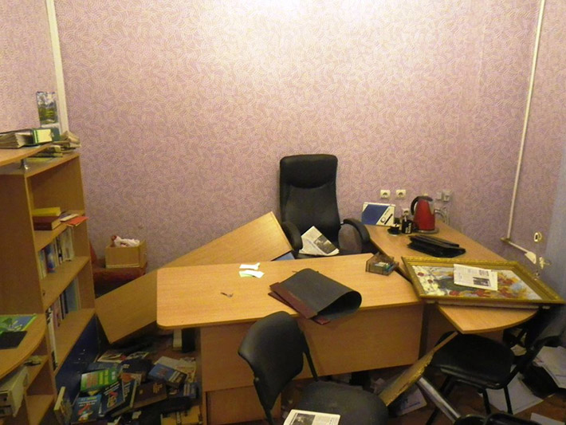
Photo from the site: Ostro
TRK “Donbass” was attacked, as was the editorial office of the TV channel “Union”. The cottage of the editor-in-chief of the internet publishing company “Island”, Sergi Garmash, was also attacked.

Civilian casualties during anti-terrorist operations
Information about the progress and consequences of anti-terrorist operations (ATOs) published by the media and understood by the general public is extremely contradictory.

We have tried to collect information on the effects of the ATOs in Kramatorsk, which occurred prior to our arrival in the region, in Mariupol, where we arrived a few hours after a firefight on May 9^{th,} and in Krasnoarmeysk, on the day of the referendum.

Ukrainian involvement in anti-terrorist operations in the Donetsk region

The confrontations in Donetsk involved actors from the Ukrainian side including army troops, internal troops, the National Guard and hastily formed battalions of police “special forces”, as well as illegal armed groups.

Involving the army in an internal conflict without declaring a state of emergency or martial law creates a situation of complete legal uncertainty. In such situations, no one understands where the limits of the permissible use of force lie, who has the right to request the mobilization of law enforcement support from the local population and where the power of law enforcement ends.

Parts of the internal troops of Ukraine have been largely unable to perform their duties. The police are disorganized and not willing to carry out orders to act decisively against any group, considering inaction to be the least dangerous option.

Under these circumstances, the Mistry of Internal Affairs and the Ministry of Defense of Ukraine have created new organizational units (OUs) of motivated individuals from the general population who want to protect the integrity of the country. The battalions of “Dnepr” and “Azov” where thus formed. However, in light of the civil conflict in Eastern Ukraine, these hastily formed structures will inevitably have to face opposition from unarmed, but aggressive masses. It is clear that such forces are not ready for such a confrontation. After a short period of preparation, they did not possess the necessary skills and they are generally poorly equipped (during the events of May 9th in Mariupol, the “Asov” battalion was not even in uniform), and they do not have the necessary instruments. An automatic machine gun should not be used to deter an aggressive crowd, since this inevitably leads to the unjustified loss of life.
The status of groups such as “Dnepr” and “Azov” is not sufficiently defined. In theory, such formations should serve as patrolmen and ensure order on the “territories liberated from the separatists and terrorists.” In reality, they are forced to engage in armed confrontation with militants, for example in the liberation of occupied buildings, and thus fulfill a function beyond what is expected of patrolmen.

The Ukrainian authorities urgently need to restore order within their own power structures in order to completely eliminate the possibility of dispatching poorly prepared and insufficiently equipped fighters in places where they may clash with hostile civilians.

At the same time, we cannot fail to note that, in many cases, the behavior of Ukrainian law enforcement demonstrates that they truly aim to minimize losses among the civilian population. One can only welcome the moderate behavior of troops at the beginning of the operation in Mariupol on May 9th, and regret that the poor organization and lack of training and equipment for law enforcement bodies led, by the end of the operation, to unnecessary casualties among civilians.
***
Our greatest concern is that local authorities have not only consented to the formation of illegal armed groups, but they actively support such formations. We are referring to the so-called battalion “Donbass”. This formation is not subject to any power exercised by Ukrainian officials and its activities are not governed by any laws. Meanwhile, soldiers of the battalion “grant themselves the power to conduct military operations, take control of populated areas and detain people. Their actions are illegal, but are conducted with the cooperation of the Ukrainian authorities.

The Ukrainian authorities must immediately put a stop to the activities of any unofficial groups that position themselves as defenders of Ukrainian statehood. Unofficial groups fighting in support of Ukrainian statehood can do as much damage as the activities of the separatists.

It should also be noted that there has been unacceptable interference by authoritative individuals into the dealings of the Ukrainian Security Forces. The most striking example of such interference is the case of the deputy Oleg Lyashko who was inexplicably involved in detentions (Watch Here) and interrogations (Watch Here); in the latter case, questions have arisen about the ill treatment of detainees.

Events in Mariupol on May 9th, 2014
It should be noted that there had been outbreaks of armed violence in Mariupol previous to those of May 9th. For example, on the evening of April 16th (around 10:00 pm local time), a crowd of people, many dressed in camouflage and wearing masks, came to the military unit number 3057 near the city center as if to negotiate, but in fact demanded surrender.
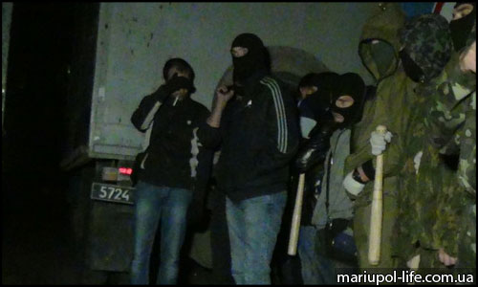
“Peace Negotiators”
After the military refused to disarm, the attackers threw Molotov cocktails onto the military base. According to the channel 1 “ORT” (VIDEO), one of the injured “peaceful civilians” explained that the cocktails had been thrown in order to illuminate the yard of the military base.
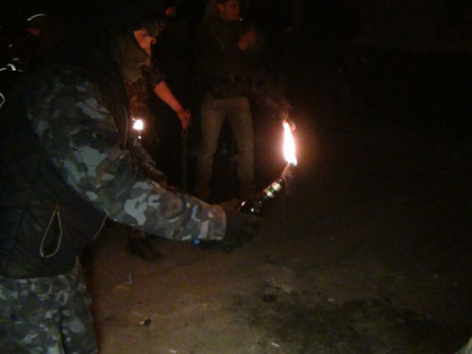
Source of Photograph

The “peaceful civilians” then broke down the gate. The military troops fired warning shots and then fired at the legs of the fighters. The following day, “Russia-24” reported that the troops opened fire on the citizens. The channel aired the statements of supposed witnesses which claimed that the doors fell down by themselves (VIDEO).

As a result of the confrontation, three of the attackers were killed (some sources report only two deaths), and sixteen people were injured. As of April 22nd, five of the injured had been discharged from the hospital (On the News). The Office of the Prosecutor General of Ukraine recognized the use of weapons as legitimate and it is difficult to argue with this conclusion. Responsibility for the death and injury of human beings lies entirely with the organizers of the attack on the military unit.

Nevertheless, a version of events that described the unprovoked shooting of civilians by the military became widespread, as did conspiracy theories about provocateurs who purposefully threw Molotov cocktails at the base. PRD supporters spread rumors about “dead bodies stashed on the military base”, that people allegedly “witnessed 19 deaths, of which only 11 people have been identified”, and that the perpetrators “sported military gear and arrived shortly before the shooting in MI-8 helicopters” (http://www.0629.com.ua/news/519472).
***
The situation became heated again during a special operation on May 7th, when the city council building was liberated from the occupation of PRD supporters (Click Here). According to press reports and eyewitnesses, the building was emptied using tear gas, without the use of firearms. Initial reports of injuries occurring during the dismantling of barricades have not been confirmed. Sixteen activists were detained by the PRD supporters. The crowd was trying to free detainees from the Primorskovo police station which had been opened in response to warning shots. The TV channel “LifeNews” claimed that “security forces repeatedly opened fire on civilians” (Clink Here), but there is no information relating to any casualties.

However, the Security Forces were not able to maintain control over the city council building and by May 8th, the PRD flag appeared over it once again. Despite the fact that the no one was injured, the city was greatly agitated by these events and rumors spread.

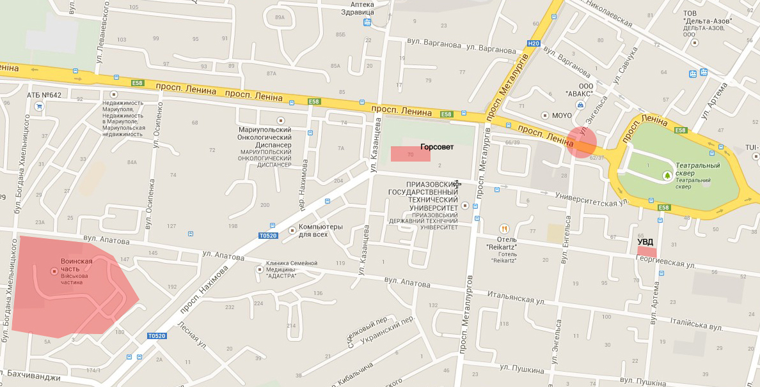

Not surprisingly, myths immediately began to develop related to the events of May 9th.
On May 9th in Mariupol, we visited all the hospitals where the wounded were being treated – the Emergency hospital and City Hospitals number 1, 2 and 9.
According to doctors, about 40 wounded people were brought to the hospitals in total, all between 12:00 pm and 3:00 pm and all were men aged 25 to 53 years old:
- Hospital No. 1 received 15 wounded; the first six were law enforcement officers. They mainly had injuries to the legs and, to a lesser extent, the torso. There were no deaths.
- Only one person was brought to Hospital No. 2 – a person who had been hit by a stray bullet while walking his dog; a bullet struck him in the heart and he died after two hours; another person was also wounded, but was not brought to the hospital.
- Hospital No. 9 would only tell us the approximate number of wounded – around 15.
- Ten people were taken to the Emergency Hospital; two were injured in the stomach, another in the leg. The wounds were serious. One of those delivered to the hospital (a soldier with a stomach wound) later died.
According to the victims and their relatives who we were able to interview, most were injured near the intersection of Lenin Avenue and Engels Street. At the same time, experts were conducting forensic analyses on three corpses. At the time of our initial survey, we were aware of five deaths. By the next day, the number had increased to ten.

On May 14th, the new police chief, Oleg Morgun, reported that during the investigation of the city council building, an eleventh corpse was found but that it “certainly wasn’t a member of the Mariupol police” (http://www.0629.com.ua/news/534419).

He also said that “all personnel where either at their workplaces or were away on sick leave. There is no one missing from the Mariupol police forces.” This statement directly contradicts that made by the leader of the Ukrainian Communist Party, Petro Symonenko who, at a meeting of the Verkhovna Rada stated, “in Mariupol, personnel of the City Police Department were shot and killed because they refused to carry out a criminal command to disperse civilians at a rally.” (Link)

This version of events is also widespread on the internet and among the city’s inhabitants. In reality, the story was quite different.

According to our sources, on the morning of May 9th, in the Ministry of Internal Affairs of Mariupol (St. George Street, 63), a meeting was held with the heads of law enforcement agencies participating in the ATO. Shortly after 10:00 am, a group of armed men without visible insignia entered the building (possibly with the aid of someone on the staff of the MIA) and occupied the first two floors. According to eyewitnesses, intensive shooting could be heard inside the building. The meeting members barricaded themselves on the second floor and called for reinforcements. The first battalion of soldiers to arrive was “Azov”, who appeared in plainclothes (they did not have uniforms). According to the Deputy Battalion Commander, Yaroslav Gonchara, the “Asov” fighters were able to retake the first floor (VIDEO). The arrival of troops from the 72nd Brigade was delayed because the inhabitants of the city inhibited the movement of their armored vehicles.

Despite their aggressive behavior (throwing stones, attempts to cover the vehicles’ sights, creating road blocks), the soldiers showed the utmost restraint and did not open fire. However, one person who was heavily intoxicated was wounded on Lenin Avenue after he threw himself at the armed vehicle that was moving at a high speed. It is possible that this shot saved his life, since the driver was unlikely to have been able to slow down in time.

Due to a lack of coordination, some of the “Azov” fighters were briefly detained upon their arrival at the Ministry of Internal Affairs.

The operation around the Ministry of Internal Affairs was significantly complicated by the assembled townspeople who did not understand what was going on. It is from here that the interpretation grew which claimed the police were shot because they refused to take the side of the people.

In a shootout over the seizure of the building, the First Company Commander of the Special Forces unit “Azov”, Rodion Dobrodomo, died. Around 1:00 pm, the Second Commander of the “Azov” force, which were dressed in police uniforms, was wounded by a sniper. The sniper was located in a neighboring building; shots were returned and the sniper was destroyed (VIDEO).

Video of the final phase of the operation, released by the Ministry of Internal Affairs, shows at least two cases of injuries suffered by unarmed citizens who were in the battle zone and at least four Ukrainian military personnel who had surrounded the building (VIDEO).
***
A significant number of townspeople were injured at the intersection of Lenin Avenue and Engels Street shortly after 12:00 pm. Most of the injuries resulted from the use of weapons by military personnel who were moving down Engels Street, away from the Ministry of Internal Affairs. This episode requires thorough investigation.

There can be no doubt that the military had no intention to attack the gathered crowd and, judging by the nature of the injuries, the shots received were not intended to kill.

Judging by the video clips of the incident, it would have been quite possible to stop the aggression of the civilians without the use of firearms, if the servicemen had had stun grenades and tear gas. Since this riot was not the first in the city, and given the on-going celebratory events, the government should have provided troops with a sufficient amount of special equipment.
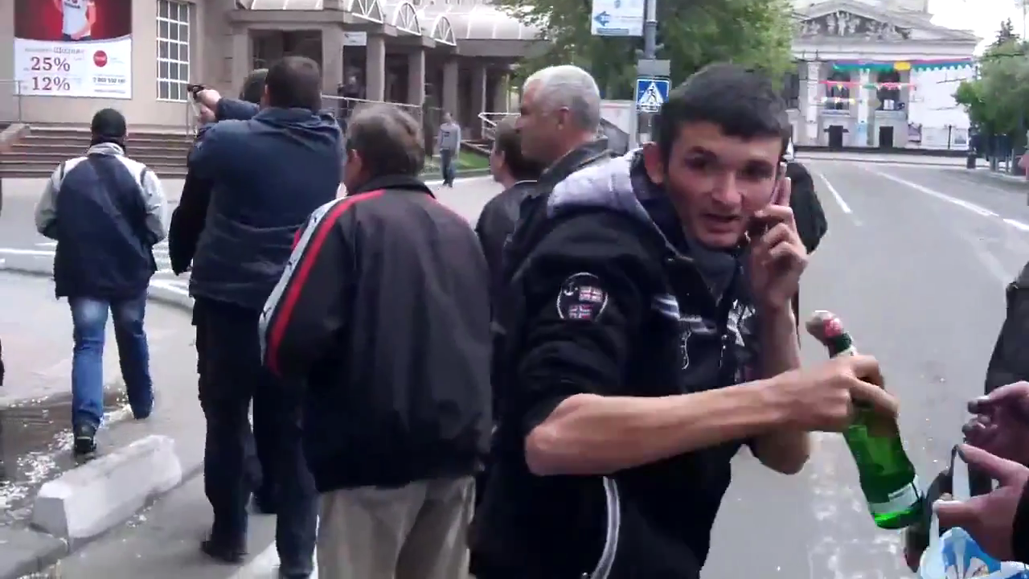
Source: VIDEO

Although the videos show people with Molotov cocktails and shooting stun guns at the military personnel, the organizers of the ATO are not absolved of liability for criminal negligence.

Of course, most of the blame for the deaths and injuries lies with those who attacked the Ministry on the holiday. Fighting in a city filled with crowds of people in the streets could not but result in casualties. However, the negligence of the authorities exacerbated the consequences.

Events in Krasnoarmeysk, May 11th, 2014
On the day of the referendum in Krasnoarmeysk, a group of armed men who claimed to represent the “Dnepr” battalion, “took custody” of the district “due to the threat of occupation”. (VIDEO) This caused an interruption in the referendum voting process (according to representatives of the PRD, however, the voting was forcefully terminated and the ballots were taken from the polling station).

Around 7:00 pm, a few dozen residents of Krasnoarmeysk protested because they did not have occasion to cast their votes. They behaved fairly aggressively and one of them even grabbed the barrel of a gun held by one of the new arrivals. As a result, they opened fire (mostly in the air and at the ground) – one person was killed on the spot and another was seriously injured and later died, with a third receiving a shot to the leg (LINK).

The Ministry of Internal Affairs of Ukraine, as well as the authorities of the Dnepropetrovsk region officially declared that the “Dnepr” battalion had not been in Krasnoarmeysk.

The “Kommersant” newspaper published an article (Found Here) stating that “Correspondent B. was able to identify in photographs from the city one of the participants in the protest. It was Andrei Denisenko, a leader from the “Right Sector” of Dnepropetrovsk, and the deputy head of the central party office which coordinates the campaign of the presidential candidate Dmitri Yarosh.

During an interview, “Memorial” representatives asked one of the senior officials of the Ministry of Internal Affairs of Ukraine “Who came to Krasnoarmeysk on May 11th?” He curtly replied, “Bandits”. He denied any involvement of official law enforcement agencies in the events.

On May 14th, the Verkhovna Rada created a temporary Investigative Commission to look into the mass killings of civilians in the cities of Odessa, Mariupol and Krasnoarmeysk, as well as others cities in the south and east of Ukraine. They should also carefully review this information.

Without waiting for the results of the investigation, the government should take drastic measures to immediately suppress activities that fall outside of the law of armed engagement. Otherwise, the responsibility for the actions of armed groups will fall on the Ukrainian authorities.

No matter by which formation the operation in Krasnoarmeysk was carried out, the actions must be evaluated as criminal.

Kramatorsk
In this section, we present information about the situation in Kramatorsk, which we obtained on May 14th while visiting the city. The situation may have changed since that time.

Two cities feature prominently in media reports about the fighting the Donetsk region: Slavyansk and Kramatorsk. There have been reports of civilian casualties in these cities, not only in the outer areas, but also in the city centers.

Here are a few examples:

Armored vehicles entered Kramatorsk - Link
Ukrainian military stormed the city which was controlled by self-defense forces
03 May, Vladimir Azin

Ukrainian armored vehicles entered the city of Kramatorsk which was controlled by self-defense forces, as reported by local media.

A fight broke out in Kramatorsk around 11:30 am. This information was confirmed by acting Interior Minister, Arsen Avakov. According to “Vesti.ua”, gunfire and explosions could be heard in the Molvik mountain region.

Militias created roadblocks on the Slovyansk side, according to Kramatorsk.INFO, shooting from heavy weaponry could be heard and there was black smoke. Locals began to hastily return to their homes when an alarm sounded to warn them of the danger.
Shortly thereafter, according to eyewitnesses, a convoy of nine armored vehicles arrived in Kramatorsk accompanied by one jeep. In the city, according to LifeNews, shots could be heard and the militias burned trolley-buses and taxis to form roadblocks.

The Ministry of the Interior of Ukraine reported the release of the local television center which resumed broadcasting Ukrainian channels. “In the areas of the television center that had been occupied by the terrorists, Kalashnikov bullets were found along with note cards written with separatist content, some prayers cards issued in Moscow and St. Petersburg and some hand-written notes about the switching-on of Russian television channels” – the agency said in a statement.

Information about the seizure of military buildings of the Ukrainian Security Service later became known. “Now the building is under the control of the National Guard of Ukraine,” reported the Ministry of Internal Affairs.

Arsen Avakov urged residents of Kramatorsk not to leave their homes. “We are moving on Kramatorsk. There is heavy fire from terrorists. A fight has ensued. We ask all residents of Slavyansk and Kramatorsk to remain indoors”, he wrote on his Facebook page.

The militia reported that self-defense fighters only held the city center. For the moment, the firing has ceased, but the militia is preparing for another assault on their positions.

According to “News Kramatorsk”, during the assault on the city, two people were killed and ten more were injured. The militia reported the deaths of two of their fighters from sniper fire.

Article Online
Moscow, May 3 /ITAR-TASS/ In Kramatorsk, in the Donetsk region, units of the Ukrainian Security Forces are conducting a special operation and fighting has erupted in the streets, reports TV channel “Russia 24”. According to unconfirmed information, there are victims. According to the correspondent, people in unmarked uniforms were “firing without warning on any moving target”.

Casualties in Kramatorsk
May 4. /ITAR-TASS/ Casualties in Kramatorsk
The renewed raid on Kramatorsk has resulted in the deaths of least six more people.

According to the Department of Health of the Donetsk region, all of the victims died of gunshot wounds. It is reported that at least 15 people have been injured.

Earlier, the Self-Defense Forces of South-East Ukraine reported that on the night of May 2nd to 3rd, ten residents of Kramatorsk were killed and 30 people were injured as a result of the collision.

At a plenary meeting on May 13th, the State Duma issued an appeal “to the governments of the world and international parliamentary organizations in connection with the threat of a humanitarian disaster in Ukraine.”

Based on the above information, when we headed to Kramatorsk on May 14th, we expected to see a picture resembling the situation in Chechnya in 2000.

Fortunately, the picture that we discovered was much different.

On the eve of May 13th, in the course of the fighting in Kramatorsk, eight Ukrainian military paratroopers were killed by the PRD militia. However, we were able to drive a taxi through several checkpoints held by PRD supporters relatively unhindered and we did not see any Ukrainian army posts.

In the center of Kramatorsk, some of the streets were blocked by burned-out trolleys, buses and cars. However there was no evidence of shootings or other damage.

Locals explained to us that in the city, there was generally no fighting or shots fired. The vehicles were set on fire on May 2nd by supporters of the PRD. On that day, a column of Ukrainian armored vehicles had been passing along the highway on the outskirts of Kramatorsk and tried to proceed into the city center. However, the militia, fearing that the Ukrainian military would try to storm the city administration building occupied by PRD supporters, built a barricade out of burned cars.

The shops in the city are operating normally (although a few remain closed), as do the pharmacies, schools, hospitals and municipals services. There have been no reported shortages of food or water. The city administration continues to carry out its functions from other buildings.

The city was only temporarily paralyzed from May 2nd to May 5th or 6th. Public transportation shut down on May 2nd and 3rd in the vicinity of the fighting and then for a couple of days afterwards, when people were afraid to go out onto the streets.

We spoke with several doctors at the city’s “Emergency Hospital” as well as city health department workers and forensic experts.

Our interlocutors in the medical professions reported that the service at the Emergency Hospital and at the city hospitals fortunately suffered no shortage of medications, dressings or lubricating oils for the medial equipment.

The ambulances have been able to move freely between Donetsk and Kramatorsk. Entry and exit from Slavyansk has also been open with the exception of a few periods of closure during firefights. The wounded from Slavyansk have sometimes been transferred to the hospitals in Kramatorsk or further on to Donetsk for more complicated procedures.

As we were told, not a single injury or death resulting from firearms or artillery occurred during the entire anti-terrorist operation of the Ukrainian military. We were able to confirm that there were no shootings. All of the fighting took place outside of the city.

During the entire period, seven residents were killed, including one woman. Two men were killed on May 2nd in the Andreyevka area during the battle for the television center. Four people were killed on May 3rd, including one woman. Apparently, the 21-year-old nurse, Yulia Izotov, died as Ukrainian forces were shooting at passenger cars, as was reported by several media outlets. According to these reports, three young men who were in the car were also killed. All were unarmed. Journalists provided inconsistent accounts of the circumstances of the shooting, except for one detail – the passenger car was near the PRD roadblock near Kramatorsk. On that day, the Ukrainian forces had tried to dismantle the checkpoint which had led to a confrontation with the militia. The circumstance of the death of Yulia Izotova and her companions must be thoroughly investigated.

There can be no justification for firing on a passenger car full of unarmed people. The seventh victim was wounded in unknown circumstances outside of the city and was being transferred to the city hospital, but died en route.

Over the course of the ATO, nineteen people were brought to urban hospitals with gunshot wounds, including one woman. None of them died. Seven of them have already been released.

Three people were delivered to the hospital in Kramatorsk during the most intense fighting on May 2nd from the area surrounding the village of Anreyevka, which is located between Slavyansk and Kramatorsk (this fighting was a struggle for control over the television tower). A woman of 36 had injuries to her lower extremities, a man of 43 had injuries to the lower extremities and a man of 19 had an injured pelvis.

The next day, four men were taken to the city hospital from the surrounding areas: a 33 year old with a stomach wound, a 29 year old who was wounded in the thigh, a 35 year old who was shot in the chest and a 47 year old who suffered a hip injury.
According to the medical professionals with whom we spoke, most of the wounded men who were brought to the hospital had gone on their own to the areas where the shootout with Ukrainian forces was occurring.

“Referendum” of May 11th, 2014
The material in this section is the result of direct observation on the day of the referendum.

Questions related the legitimacy of the referendum
The decision to hold a referendum was made by “the Council of representatives of the territorial communities, political parties and public organizations of the Donetsk region” of April 22nd, 2014. This Council also accepted the “Provisional Regulations on the Local Referendum in the Donetsk Region”.

This body is not provided for by the legislation of Ukraine, has not achieved legitimacy through elections and therefore does not have the authority to conduct a referendum or to determine the results thereof. This Council was established on the basis of the self-proclaimed “People’s Coordinating Council of the Donetsk region” after a majority of the deputies of the legitimately elected Donetsk Regional Council refused to convene an extraordinary session – according to the testimony of the separatists themselves, only three deputies appeared at the planning meeting.
Quote from the Memorandum of 13.04.2014
On the 5th and 6th of April, 2014, the Coordinating Council of the People’s Republic of the Donetsk region appealed through the media and to the Regional Council of Deputies a proposal to the leaders of the Donetsk Regional Council to convene an extraordinary session of the Regional Council at 12:00 pm on April 7th, 2014. Draft documents had been prepared for consideration by the Coordination Council of the People’s Republic of Donetsk on the status of the Donetsk region. However, on 12:00 pm on April 7th, 2014, only three deputies of the Regional Council appeared. The session was therefore not held. The Deputies refused to perform their duties.
Given the will of the voters in the Donetsk region, representatives of the territorial communities, political parties and public organizations of the Donetsk region have assembled in the session hall of the Donetsk Regional Council and have begun the process of taking responsibility to fulfill the will of the voters of the Donetsk region (Document Online).

A separate law on local referendums, referred to in Article 7 of the Law of Ukraine “Regarding local government in Ukraine”, which refers to ‘Provisional Regulations’, has not yet been adopted. However, within the meaning of this article, it is clear that the right to administer a referendum belongs to the authoritative bodies of the territory where the referendum is to be held (according to the abolished law “On national and local referendums”, Article 12 stipulated that local referenda shall be nominated by the relevant local councils of the People’s deputies). Thus, by holding this referendum, the “Council of representatives of the territorial communities, political parties and social organizations in the Donetsk region” usurped the rights of the Donetsk Regional Council.
Furthermore, Article 7 of the Law of Ukraine “On Local Self-Government in Ukraine” states,
- Any question referred to by the Constitution of Ukraine, this Law, and other laws administered by local governments can be subject to a local referendum.
- Issues related to the application of the law by public authorities cannot be decided through a local referendum.

Under no Ukrainian law are the issues of changes to the country or the State attributed to local government. Similarly, “matters relating to the constitutional and legal status of the People’s Republic of Donetsk” as referred to in the “Provisional Regulations”, are not attributed to local government.
The referendum itself was legally flawed and had not been properly published – even now, after the referendum, the provisions can only be found on a few obscure sites online. The questions on the referendum were worded as follows: “Do you support the act of State independence of the People’s Republic of Donetsk?” Meanwhile, the text of the Act was not properly communicated to the voters. One could only access it online or by receiving a flyer from the occupied regional administration building.

The text of the “Act of State Independence of the People’s Republic of Donetsk” contains false information – it alleges that the document was proclaimed on April 7th, 2014 by the Regional Council of Donetsk. However, the regional council issued no such document.

It is important to note that the City Council of Donetsk also did not acknowledge the legitimacy of the referendum on support of the “Act”. This was confirmed by the City Council Secretary, S.V. Bogachev during a conversation with representatives of HRC “Memorial”, which took place in the city administration building on May 7th, 2014.

Separately, it should be emphasized that neither in the text of the referendum, nor in any other document are the legal consequences of the vote’s outcome identified. It was not surprising, therefore, that not only ordinary voters, but also members of the Electoral Commission imagined the consequences of a positive answer to the referendum question in different ways – from the notorious “federalization” to immediate annexation by Russia.

Violations during the preliminary stages (prior to voting day)
Although section VI of the “Provisional Regulations” provides for “the right to freely and fully discuss the referendum, official referendum materials, the possible consequences of the referendum, and to campaign for or against the issue of the referendum”, the ability to freely speak out against the supporters of act for independence was absent – the local media were subject to pressure, activists campaigning for the preservation of the unity of Ukraine and/or against the referendum as such, were subject to attacks. As an example, we can point to a case that was not covered by the media – on May 9th, in Druzhkovka, a young man (a resident of the village Gornyak) made negative comments about the pro-referendum promotional flyers, and in response, was shot in the leg by a non-lethal weapon. The young man was transferred to the hospital where he received treatment.

The general character of the “freedom” to campaign is evident in the fact that the flag of Ukraine was effectively banned – the only building on which it could be seen was that of the Donetsk City Council. PRD activists forcibly removed Ukrainian flags from administrative buildings, schools, and homes. Wearing national symbols or the colors of the national flag became unsafe. The offices of those parties advocating for the unity of Ukraine were forced to close after coming under attack.

Most of the requirements of section IV of the “Provisional Regulations” (“Lists of participants in the referendum”) were routinely flouted. Until May 10th, there was no information on the locations of the election commissions and polling stations – obtaining or amending the list was technically impossible.

Although the Provisional Regulations state that the “districting of the referendum must be decided no later than three days prior to voting”, voters and journalists learned about their districts and polling places no earlier than May 10th.

In accordance with the regulations, observers were required to register at the territorial election commissions – since these locations had not been announced, this procedure was made virtually impossible.

Organizational and voting irregularities on the day of the referendum
On May 11th, the day of the referendum, the representatives of “Memorial” were able to interview eight Election Commission Chairmen in the course of visits made to polling stations in Voroshilov, Lenin and Proletariat districts. Additionally, we were able to observe the voting process at several sites and spoke with members of the Voroshilov Territorial Election Commission and a member of the Central Election Commission.

The designated organizers of the referendum claimed that, “although there are many territorial Election Commissions in Donetsk, the local authorities agreed to re-register them at the Central Election Commission of the PRD as referendum commissions” (Article Online). This is not true, however. Although there were fewer election commission than usual, we visited sites where fewer than half of the commission members had any experience.

The number of Electoral Commissions was found to be four times fewer than for regular elections, which explains the unusually high number of voters in the first few hours. Apparently, four and sometimes five sites were combined; not so much to create the impression of a high number voters, but due to a lack of adequate facilities (many agencies refused to provide space for the voting) and a due to a lack of election commissioners willing to work on the referendum (members of the referendum commission were working on a volunteer basis, without pay). At most of the polling stations, armed men who were not members of law enforcement stood at the entrances.

In the city center, in the Voroshilov voting district, polling booths and ballot boxes generally met the standards; however, in areas that are not in the center of Donetsk (in the Proletariat, Lenin, Kalinin and Budennovsk districts) lock boxes were non-existent. In the Proletariat district, cardboard boxes were used instead of regular ballot boxes.

The text of the “Act of State Independence of the People’s Republic of Donetsk” was not posted at any of the polling stations that we visited. In fact, those participating in the referendum generally had an intuited perception of the vote’s subject matter.

The Provisional Regulations were also not posted. Moreover, eight of the responding Electoral Commission chairpersons had only one copy of the text and another had only heard about it – the rest did not have any idea where to find the text or whether it existed at all and redirected the questions to their superiors.

Voter lists were not drawn up, since referendum organizers had neither the time nor the resources and they could not get access to the Ukrainian Central Election Commission. According to official (published) information, the electoral commission for the referendum used voter lists from 2012 (which were illegally obtained from the local electoral commissions). However, we only saw such lists in the areas of the city center, in the Voroshilov district. In this case the lists were not properly bound into book form and were printed on single unbounded sheets. At one of the six polling stations we visited in the Voroshilov district in the middle of the day, we received information that about a quarter of all voters were on additional lists. At the rest of the commissions, such statistics were not gathered.

However, at a significant number of polling stations there were no lists at all – all of the people attending the election were added to an empty chart.

In order for such an option to be considered legal, the “Provisional Regulations” provides for the “compilation of lists of referendum participants in exceptional circumstances” – in reality, this procedure became the rule rather than the exception.
- In the event of unforeseen circumstances that lead to the inability to make advance preparation and transmission to the individual districts of lists of referendum participants, such lists may be compiled on the day of voting by the precinct commission itself.
- Voters who arrive on the day of voting to such a district, can only be included on the list by commission representatives upon the presentation of a Ukrainian passport.

Under this protocol, there are not even registration requirements for the Donetsk region. In practice, some of the electoral commissions verified the residence of voters and others did not. One of the Electoral Commission Chairpersons told us that residents of the Lugansk region were allowed to vote. This practice probably has more to do with the lack of experience and awareness of the Electoral Commissioners than conscious manipulation of the results.

Electoral Commissions number 3 and 4 of the Lenin District not only lacked a pre-established list of voters, but they covered the same territory. A Chairman of the Electoral Commission number 3 naively explained to us that “residents residing on the territory of the Lenin District are not obligated to vote at one precinct or another.” Thus, residents of the area were free to vote twice (meaning that the turnout could reach 200%).

At all of the polling stations, even those that had preliminary lists, not only residents of the territory could vote, but also those who happened to be present and any other residents of the Donetsk region. Nothing prevented any resident of the Donetsk region from voting and nothing prevented them from voting at other polling stations (in the absence of voter lists) afterwards. We know of several cases of multiple voting at the same location which was carried out for experimental purposes. For example, Donetsk residents who are known to us, were able to vote five times at the electoral commissions in Budennovsk and Kalinin regions. None of these electoral commissions had voter lists or polling booths.

Referendum ballots were printed in black ink on plain paper and had no protection against counterfitting or even mere copying. Except for one area in the Voroshilov district, ballots were not even assured by the signature of the Chairman or a member of the commission.

The procedure for filing complaints against the electoral commissions were very vague and, in practice, they were not prepared to consider complaints. When visiting the EC number 5 in the Voroshilvo district, we observed an episode in which a young man came to vote and drew the attention of the EC Chairwoman to the fact that the paper seal on the ballot box had come unstuck (apparently due to a poor adhesive) and the box was therefore not sealed. Instead of inviting him to file a complaint and taking the necessary (procedural) actions (e.g. Article 85 of the Law on Elections of People’s Deputies which reads: “In case of damage to the ballot box during voting, it shall be sealed by the chairman and not less than three members of the Election Commission, representing different parties, in such a way as to make it impossible to remove or add additional ballots”), the EC Chairwoman accused the young man of having deliberately broken the seal and promised the “bring him to order.” After she made a phone call, three people resembling militants ran into the polling station and accused the young man of being a “provocateur” and “Banderovets”. They tried to take him to a back room, away from prying eyes. Not without difficulty, we managed to convince the EC Chair that the scandal would not be worth it and the young man was released. Having not received any response from the complaint, he was forced to leave the polling station.

Vote Counting
Many polling stations closed a few hours earlier than 10:00 pm, as planned. At the Proletariat EC number 3, we witnessed an incredible scene –at 5:00 pm, one of the ballot boxes was already opened and they began to count the votes while the voting process was still going on sluggishly.
Formally, the “Provisional Regulations” contain a reference to election observers, but in practice they were virtually absent. We did not see any observers at any of the districts (although the EC in Voroshilov claimed that someone had registered with them as an observer). One of the few issues on which the EC Chairmen and women gave the most consistent response was the question relating to the possibility to observe the counting of the votes; the answer was almost always negative and only in one district was a readiness to allow observers verbally expressed. Apparently, no one oversaw the counting of the ballots, so the answer to the question “when and where will the votes be counted?” is not entirely clear. There is evidence that in many local ECs in Donetsk, ballots were sent to the Regional Election Commission before being counted and on to the Central Election Commission (Article Online)

The speed with which the results of the referendum were announced casts doubt on their credibility. Final figures were released two hours after the official closing of the polls. Such rates are plainly impossible, even with normal voter turnout and with experienced people working the polls.

In this case it is impossible to determine the actual rate of voter turnout, given the lack of voter lists and the large number of people voting in districts where they do not reside. The announced figures are very implausible.

According to the official organizers of the referendum, voter turnout in Donetsk was more than 80%, which is contrary to our observations and to simple arithmetic calculation.

According to the Central Election Commission, there are 706,000 registered voters in Donetsk. According to the organizers of the referendum, 118 fixed polling stations were opened. Of the average number of voters in the area – around 6,000 – 4,800 of them voted, i.e. an average of six people would have had to vote every minute. This is implausible even if the members of the Electoral Commissions had been more skilled.

Conclusions
The referendum held on May 11, 2014 cannot be considered legitimate because:
- The staging of the vote did not comply with Ukrainian legislation
- The organizers of the referendum had no legal authority to carry out the vote
- There was no freedom to campaign
- Voters were not properly informed about the subject of the referendum or the possible consequences
- The provisions of the referendum were in themselves legally flawed and were not observed
- Voting took place with gross violations of accepted standards
- The methodology of the referendum excludes the possibility of a reliable estimation of its results

According to unconfirmed reports, this man is currently in Donetsk.

