CIVIC SOLIDARITY PLATFORM AND INTERNATIONAL PARTNERSHIP GROUP ON AZERBAIJAN
STATEMENT ON STOPPING THE HARASSMENT AND INTIMIDATION OF ACTIVISTS AND JOURNALISTS IN AZERBAIJAN
JULY 23, 2012

We, the undersigned members of the Civic Solidarity Platform and the International Partnership Group on Azerbaijan (IPGA), urgently call on the Council of Europe, the EU and the Organization for Security and Co-operation in Europe (OSCE) to press the Azerbaijani government to immediately stop the harassment and intimidation of civil society activists and journalists in Azerbaijan, and to conform to international standards and commitments on freedom of expression and on the rights of human rights defenders.

Fears that harassment would intensify in the aftermath of the 2012 Eurovision Song Contest appear to have been well-founded. Harassment increased after an adviser to President Ilham Aliyev, Ali Hasanov, publicly threatened civil activists at a conference just days after the Eurovision final. On 31 May 2012, at a conference entitled ‘The role of NGOs in the development of civil society’, Hasanov warned that opposition activists“ should not dare appear in society” and urged conference attendees to show ‘public hatred’ against these individuals.

A speech by President Aliyev, during a Cabinet of Ministers meeting on Wednesday 11 July 2012, provided further cause for concern when he branded civil activists “anti-nationalist forces” and “traitors to the nation” for exposing human rights problems in the country ahead of the song contest.

We are shocked and alarmed at these statements and believe that the government of Azerbaijan is stepping up its campaign of intimidation and interrogation of activists and critical journalists¹ in retaliation for their extensive work in the lead up to the Eurovision.

Perhaps the most emblematic of this harassment is the arrest and detention, on 12 June 2012, of photographer Mehman Huseynov² on hooliganism charges. Huseynov was very active in Sing for Democracy, a civil society campaign that sought to expose and seek improvements to Azerbaijan’s human rights record ahead of the Eurovision Song Contest. His photographs were extensively disseminated in social networks and used by local and international media and other organizations. His arrest seems to have been clearly intended to intimidate and punish him for his activism, and to send a warning signal to others. Although Huseynov has since been released, the politically-motivated criminal charges against him still stand.

These actions contravene Azerbaijan’s obligations as a member state of Europe’s oldest human rights organisation, the Council of Europe. They are even more worrying in light of the recent Council of Europe Parliamentary Assembly Resolution 1891 (2012) on the situation of human rights defenders in member states. The Resolution calls on member states to “stop accusing human rights defenders of being extremists or agents of foreign powers unless there exists compelling evidence to this effect”.

Moreover, the Resolution appeals to member states to put an end to any administrative, fiscal or judicial harassment of human rights defenders, to create an enabling environment for their work, and to ensure, in all circumstances, that they are able to carry out their activities in accordance with international human rights standards and relevant national legislation.

As a member of the United Nations Security Council, Azerbaijan should uphold universal United Nations standards, such as the Declaration on Human Rights Defenders. In her report to the Human Rights Council in 2010, the Special Rapporteur on the situation of human rights defenders, Margaret Sekaggya, underlined that “the growing characterization of human rights defenders as ‘terrorists’, ‘enemies of the State’ or ‘political opponents’ by State authorities and State-owned media is a particularly worrying trend, as it is regularly used to delegitimize the work of defenders and increase their vulnerability”.

This on-going retaliation and politically motivated persecutions of activists and journalists³ in Azerbaijan since the Eurovision Song Contest indicate that the government is determined to silence critical voices. Azerbaijan’s international partners must view these worrying trends as a signal of a potentially broader crackdown against critical activists and take immediate action.

In the aftermath of the Eurovision Song Contest, and, with international attention on Azerbaijan diminishing, we urgently appeal to the Council of Europe, EU member states, and the OSCE to publicly highlight that intimidation and harassment of activists in Azerbaijan is unacceptable and to call on the Azerbaijani government to put an end to these practices.

Albanian Helsinki Committee

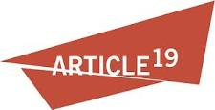 Article 19

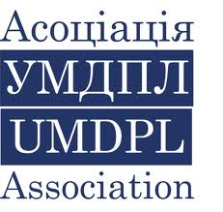 Association of Ukrainian monitors on Human Rights conduct in Law Enforcement (Association UMDPL) (Ukraine)

 Belarusian Helsinki Committee

 Belarusian Human Rights House in exile, Vilnius

_______________________

³ Human Rights Watch - Azerbaijan: Reporter Sentenced on Spurious Charges - 12 June 2012 http://www.hrw.org/news/2012/06/12/azerbaijan-reporter-sentenced-spurious-charges

 Centre for Civil Liberties (Ukraine)

 Centre for the Development of Democracy and
Human Rights (Russia)

 Center for National and International Studies (CNIS), Baku, Azerbaijan

Freedom Files Freedom Files (Russia)

 Georgian Young Lawyers’ Association

 Golos Svobody (Kyrgyzstan)

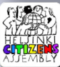 Helsinki Citizen’s Assembly – Vanadzor (Armenia)

 Helsinki Foundation for Human Rights (Poland)

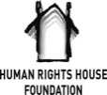 Human Rights House Foundation (Norway)

 Human Rights Monitoring Institute (Lithuania)

 Human Rights Watch

 Index on Censorship

 International Partnership for Human Rights (Belgium)

Media Diversity Institute

 Moscow Helsinki Group

 Netherlands Helsinki Committee

 Norwegian Helsinki Committee

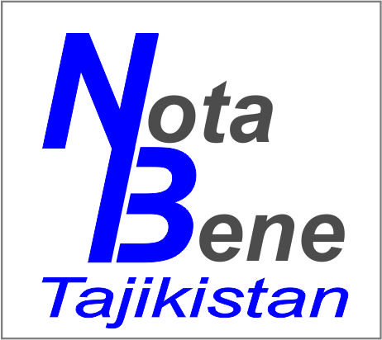 Nota Bene (Tajikistan)

 PEN International

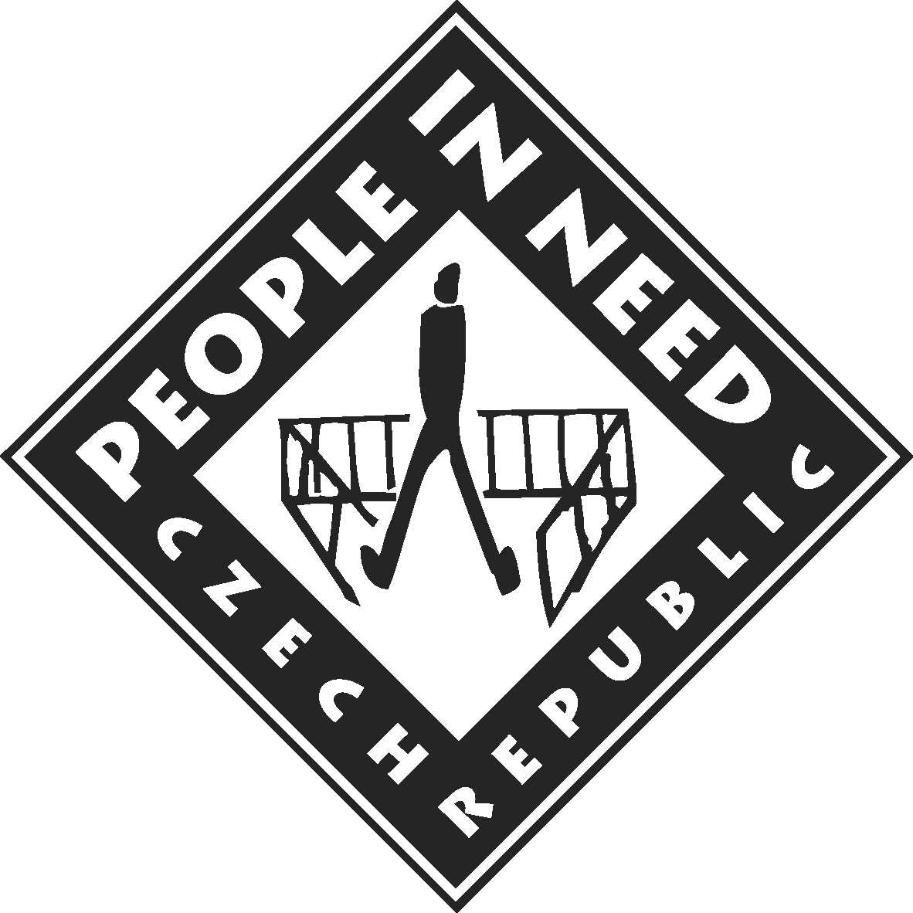 People in Need, Czech Republic

 Promo LEX Association (Moldova)

 Reporters Without Borders

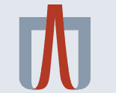 Ukrainian Helsinki Human Rights Union

 Youth Human Rights Movement

2¹ IPGA - Campaign for Free Expression in Azerbaijan - Freedom of Expression Situation Worsens in Aftermath of Eurovision – 25 June 2012 - http://azerbaijanfreexpression.org/library/statements/freedom-of-expression-situation-worsens-in-aftermath-of-eurovision/ 2 Human Rights Watch - Azerbaijan: Retribution Against Photographer – 14 June 2012 http://www.hrw.org/news/2012/06/14/azerbaijan-retribution-against-photographer

