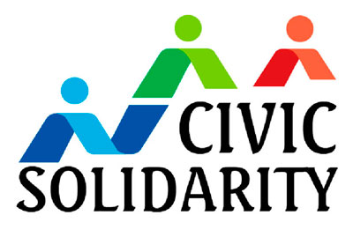

**NGOs Call on the OSCE to Take Action on Ukraine,**

**Closing Space for Civil Society, Torture and Intolerance**

On 2-3 December 2014, civil society organizations from across the OSCE region met in Basel to endorse [recommendations](http://www.civicsolidarity.org/sites/default/files/civil_society_recommendations_to_the_mcm_in_basel_december_2014_final.pdf) to OSCE participating States about to meet in the annual Ministerial Council.

The civil society recommendations focus on key human rights issues across the OSCE space, including the situation in Ukraine, the assault on civil society by a number of OSCE states, including efforts to brand NGOs as foreign agents and bar their access to necessary funding, the need to do more to prevent torture, and the increasing wave of intolerance and rise of racist parties throughout the OSCE space, both East and West of Vienna.

“Meeting here in Basel at times of growing repressions against our colleagues in Azerbaijan, Russia and various countries in the region, is unique for the Civic Solidarity Platform. We wish that the Ministerial Council and OSCE institutions will respond to our recommendations and call for concrete action in key human dimension areas for the better of citizens of the whole OSCE region”, says Brigitte Dufour, director at the International Partnership for Human Rights.

Among the documents prepared by the conference is the [Basel Declaration](http://www.civicsolidarity.org/article/1052/basel-declaration), which calls on the OSCE to develop a comprehensive action plan to combat racism, xenophobia, discrimination, hate crimes and other forms of intolerance in cooperation with civil society.

“The Declaration calls for the OSCE to include reporting on discrimination during electoral campaigns as a key task for all election observation missions and increase its institutional focus on promoting tolerance education,” says Ralph du Long, a spokesman at UNITED for Intercultural Action.

The conference participants presented their recommendations to OSCE Chairman in Office and Swiss President Didier Burkhalter and incoming Serbian chairmanship.

*For more information please contact:*

*Andrei Aliaksandrau –* [*aliaksandrau@gmail.com*](mailto:aliaksandrau@gmail.com) *+375 29 7120757*

*Ralph du Long –* [*ralph@unitedagainstracism.org*](mailto:ralph@unitedagainstracism.org) *+31-6-523-14091*